For
I B.Tech I & II SEMESTER

NAME OF THE STUDENT:
ROLL NO: | BRANCH:
DEPARTMENT OF
BASIC SCIENCES AND HUMANITES

CHEMISTRY SYLLABUS

UNIT I

Structure and Bonding Models
Fundamentals of Quantum mechanics, Schrodinger Wave equation, significance of Ψ and Ψ², particle in one dimensional box, molecular orbital theory – bonding in homo- and hetero nuclear diatomic molecules – energy level diagrams of O2 and CO, etc. π-molecular orbitals of butadiene and benzene, calculation of bond order.
UNIT II
Modern Engineering materials
Semiconductors – Introduction, basic concept, application
Super conductors-Introduction basic concept, applications.
Supercapacitors: Introduction, Basic Concept-Classification – Applications.
Nano materials: Introduction, classification, properties and applications of Fullerenes, carbon nano tubes and Graphines nanoparticles.

UNIT III

Electrochemistry and Applications
Electrochemical cell, Nernst equation, cell potential calculations and numerical problems, potentiometry- potentiometric titrations (redox titrations), concept of conductivity, conductivity cell, conductometric titrations (acid-base titrations).
Electrochemical sensors – potentiometric sensors with examples, amperometric sensors with examples.
Primary cells – Zinc-air battery, Secondary cells –lithium-ion batteries- working of the batteries including cell reactions; Fuel cells, hydrogen-oxygenfuel cell– working of the cells. Polymer Electrolyte Membrane Fuel cells (PEMFC).

UNIT IV

Polymer Chemistry
Introduction to polymers, functionality of monomers, chain growth and step growth polymerization, coordination polymerization, with specific examples and mechanisms of polymer formation.
Plastics –Thermo and Thermosetting plastics, Preparation, properties and applications of – PVC, Teflon, Bakelite, Nylon-6,6, carbon fibres.
Elastomers–Buna-S, Buna-N–preparation, properties and applications.
Conducting polymers – polyacetylene, polyaniline, – mechanism of conduction and applications. Bio-Degradable polymers - Poly Glycolic Acid (PGA), Polyl Lactic Acid (PLA).

UNIT V

Instrumental Methods and Applications
Electromagnetic spectrum. Absorption of radiation: Beer-Lambert’s law. UV-Visible Spectroscopy, electronic transition, Instrumentation, IR spectroscopies, fundamental modes and selection rules, Instrumentation. Chromatography-Basic Principle, Classification-HPLC: Principle, Instrumentation and Applications.

Textbooks:
- Jain and Jain, Engineering Chemistry, 16/e, DhanpatRai, 2013.
- Peter Atkins, Julio de Paula and James Keeler, Atkins’ Physical Chemistry, 10/e, Oxford University Press, 2010.

Reference Books:
- Skoog and West, Principles of Instrumental Analysis, 6/e, Thomson, 2007.
- J.D. Lee, Concise Inorganic Chemistry, 5th Edition, Wiley Publications, Feb.2008
- Textbook of Polymer Science, Fred W. Billmayer Jr, 3rd Edition

UNIT I

Structure and Bonding Models

Molecular Orbital Theory:
- It was proposed by Hund and developed by Mullikan
- It explains about
- Chemical bond formation
- Relative bond strengths
- Dia or paramagnetic nature of molecules
Postulates of MO Theory:
- The atomic orbital's of the combining atoms overlap to form new orbital's called Molecular orbitals.
- The number of M.O. formed is equal to the number of overlapping atomic orbitals.
- Maximum capacity of a M.O. is two electrons with opposite spins.
- Only those atomic orbitals can combine to form which have comparable energies as well as proper orientations.
- According to LCAO method, the linear combination of atomic orbitals can takes place either by addition or subtraction of the wave function of atomic orbitals involved
- Molecular orbital obtained by the addition of wave function(Constructive interaction) of atoms is called bonding molecular orbital
Ψ(MO)= Ψ_{A} + Ψ_{B}
Energy of bonding molecular orbital's is less than that of the constituting atomic orbitals
Characteristics of BMOs
- It possesses high electron density in the region between the two nuclei.
- It imparts stability to the molecules
- Every electron in it makes contribution to the attraction of two combining atoms
- It is only obtained, when the lobes of the combining atomic orbitals possess the same sign
- Molecular orbital obtained by the subtraction of wave function (Destructive interaction) of atoms is called anti-bonding molecular orbital
Ψ*(MO)= Ψ_{A} – Ψ_{B}
Energy of anti bonding molecular orbitals is less than that of the constituting atomic orbital
Characteristics of ABMOs
- It possess zero electron density in the region between the two nuclei
- It imparts instability to the molecules
- Every electron in it makes contribution to the repulsion of two combining atoms
- It is only obtained, when the lobes of the combining atomic orbitals possess the opposite sign
- Probability of bonding molecular orbital (Ψ²) formation greater than that of the anti bonding molecular orbital(Ψ*²).
Ψ² = (Ψ_{A} + Ψ_{B})² = Ψ_{A}² + Ψ_{B}² + 2 Ψ_{A} Ψ_{B}
Ψ*² = (Ψ_{A} - Ψ_{B})² = Ψ_{A}² + Ψ_{B}² - 2 Ψ_{A} Ψ_{B}
- The shape of the M.O. formed depends on the type of the combining atomic orbitals.
- The bonding molecular orbitals are represented by σ, π, δ, etc. Whereas anti bonding molecular orbitals are represented by σ*, π*, δ*, etc
- Inner orbital M.O which do not take part in bond formation, are called non-bonding M.O.
- The filling of M.O. takes place according to
Aufbau principal, Pauli exclusive principal and Hunds rule of maximum multiplicity.
Conditions for the formation of Molecular Orbitals:
- The energies of combining atomic orbitals should of similar magnitude
Ex: 1s atomic orbital can overlap only with 1s atomic orbital only but not with 2s
2s can atomic orbital can overlap only with 2p_{x} atomic orbital; 2p_{x} with 2p_{x,} 2p_{y} with 2p_{Y} and 2p_{Z} with 2p_{Z.,} But 2p_{x} cannot with 2p_{Y} or 2p_{Z.}
- Combination of Atomic orbitals takes place only, if overlapping takes place to a considerable expent
- The combining atomic orbitals should possess the same symmetry about the molecular axis
p_{Z} orbitals of an atom will not overlap with an s-orbital of another atom.

Shapes of Molecular Orbitals:
Overlapping of 1s atomic orbitals:
Overlapping of 1s atomic orbitals yield the formation of σ1s bonding and σ*1s anti bonding molecular orbitals,
Note: Overlapping along the inter nuclear axis yields sigma (σ) molecular orbitals.
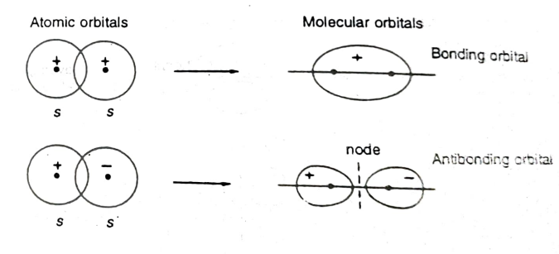
Similarly overlapping of 2s with 2s result the formation of σ2s B.O. and σ*2s A.B.Os.

Overlapping of p_{x} atomic orbitals:
Overlapping of p_{x} atomic orbitals yields the formation of σ p_{x} bonding and σ* p_{x} antibonding molecular orbital's
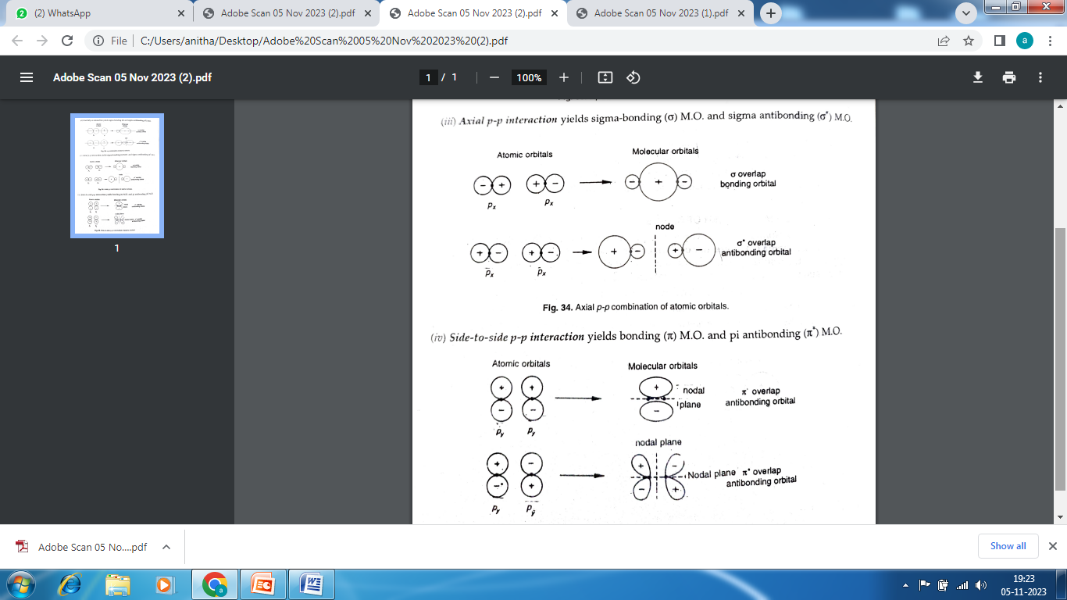

Axial p-p interaction yields σ bonding M.O. and σ antibonding M.O.
Overlapping of p_{y} or P_{z} orbitals:
Note: Side to side p-p interaction yields pi bonding (π) M. O. and pi (π) antibonding M.O.
The relative energies of first ten M.O. in increasing order :
- For H₂ to N₂ molecules
σ(1s) < σ*(1s) < σ(2s) < σ*(2s) < π(2p_{y}) = π(2p_{z}) < σ(2p_{x}) < π* (2p_{y}) = π* (2p_{z}) < σ*(2p_{x})
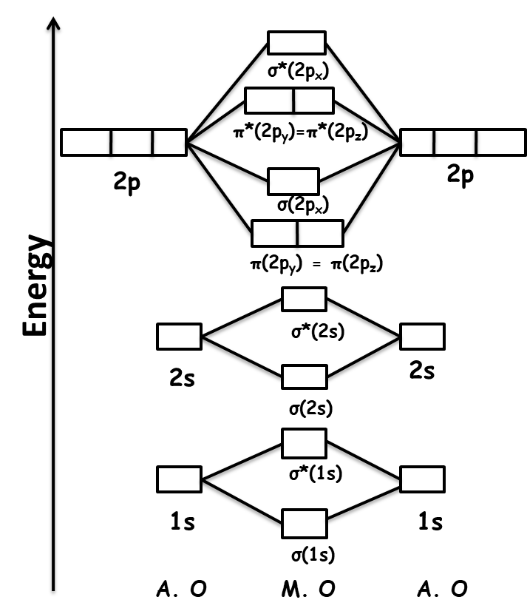
Common M.O. energy level diagram for H₂ to N₂ :

(2) For O₂ to Ne₂ molecules
σ(1s) < σ*(1s) < σ(2s) < σ*(2s) < σ(2p_{x}) < π(2p_{y}) = π(2p_{z}) < π* (2p_{y}) = π* (2p_{z}) < σ*(2p_{x})
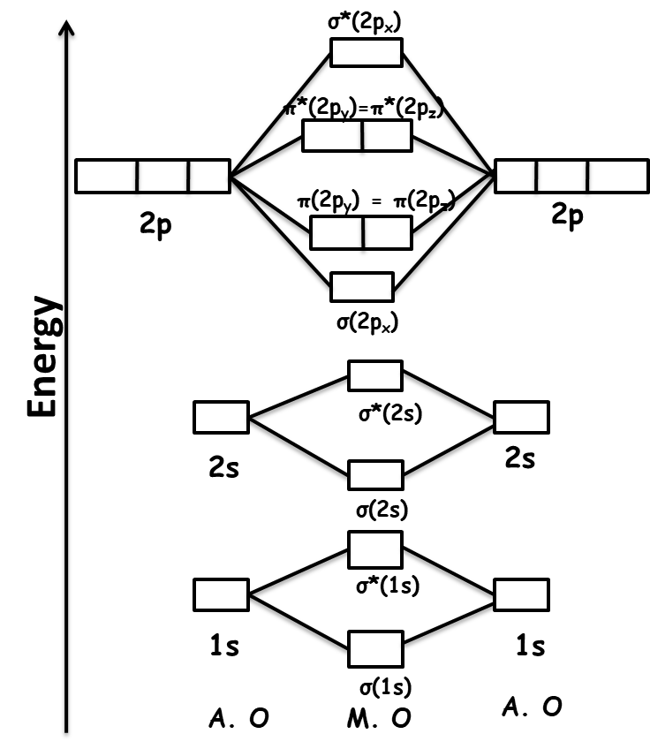
Common M.O. energy level diagram for O₂ to Ne₂ :

Bond order of a molecule
Bond order = no. of e⁻ in the B. M. O - no. of e⁻ in the A. B. M. O.
2
= N_{b}-N_{a}
2
- A negative or zero bond order means that the molecule is unstable and does not exist
- A positive value of bond order, greater is the stability of the molecule.
- Greater the value of the bond order, greater the stability of the molecule.
- Bond length is inversely proportional to the bond order
- Higher the bond order higher the dissociation energy
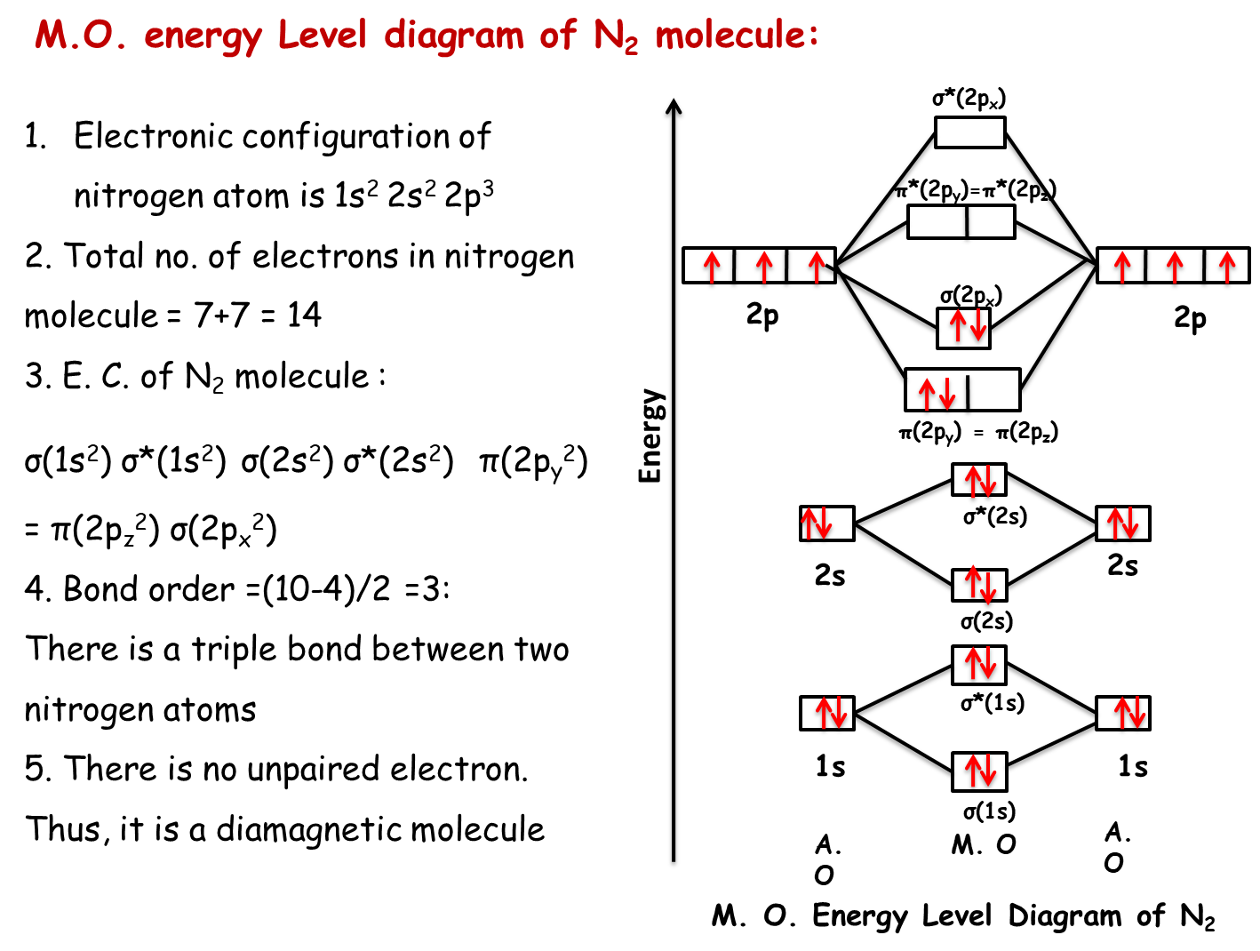

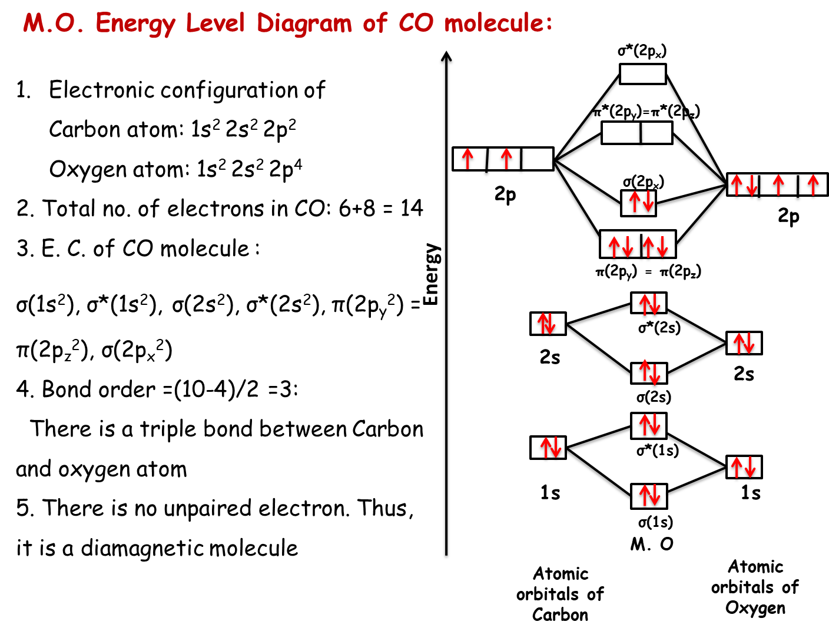

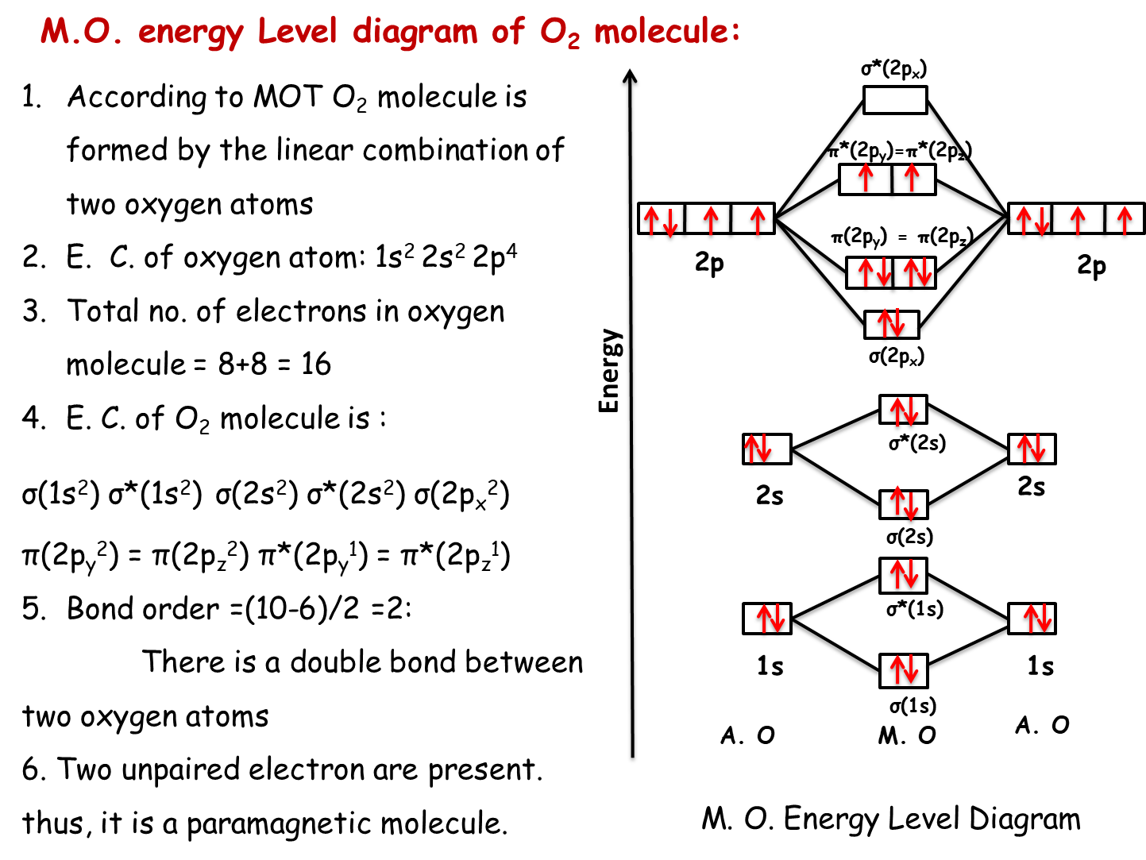

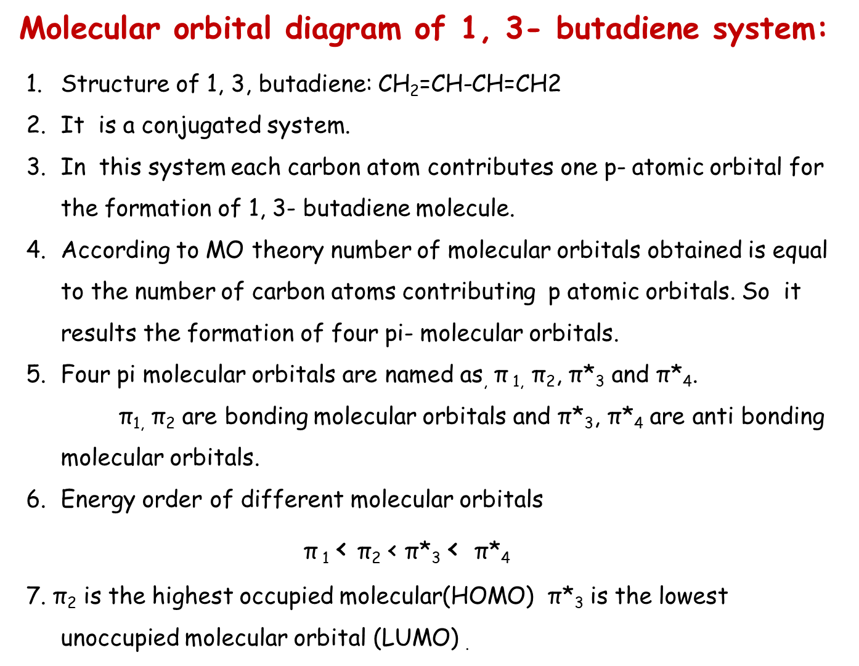

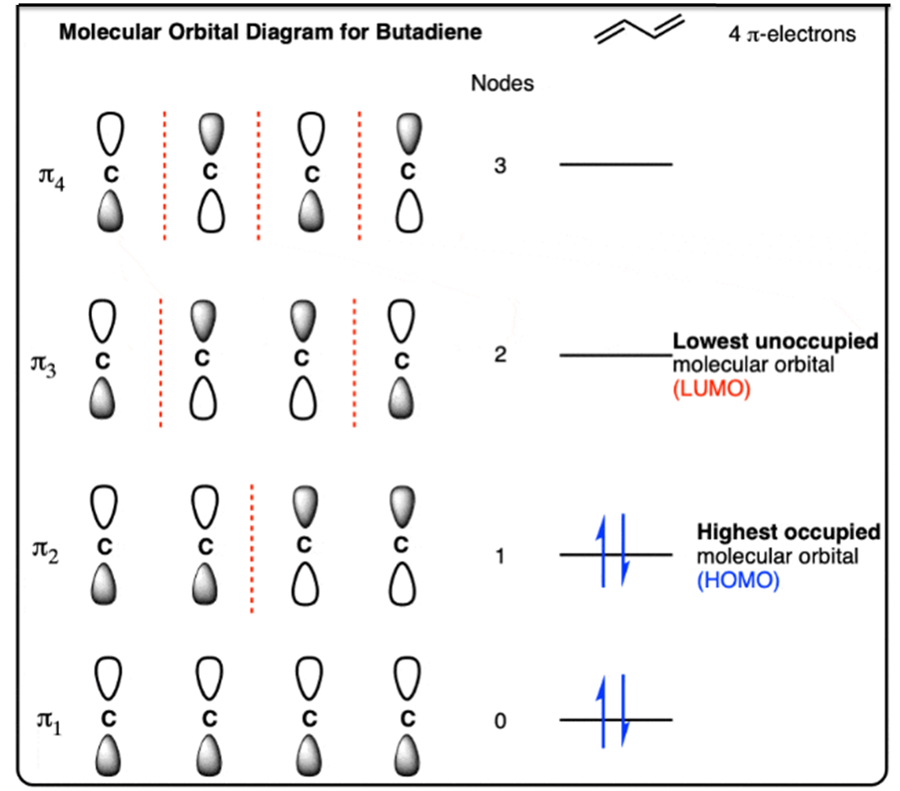

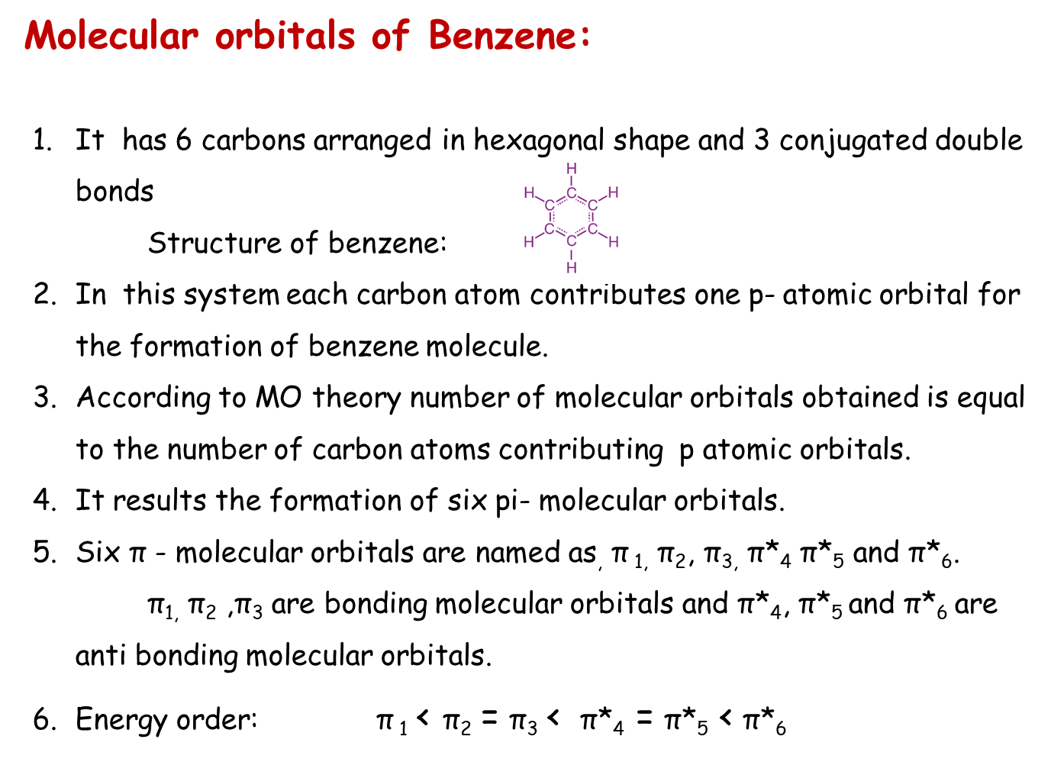

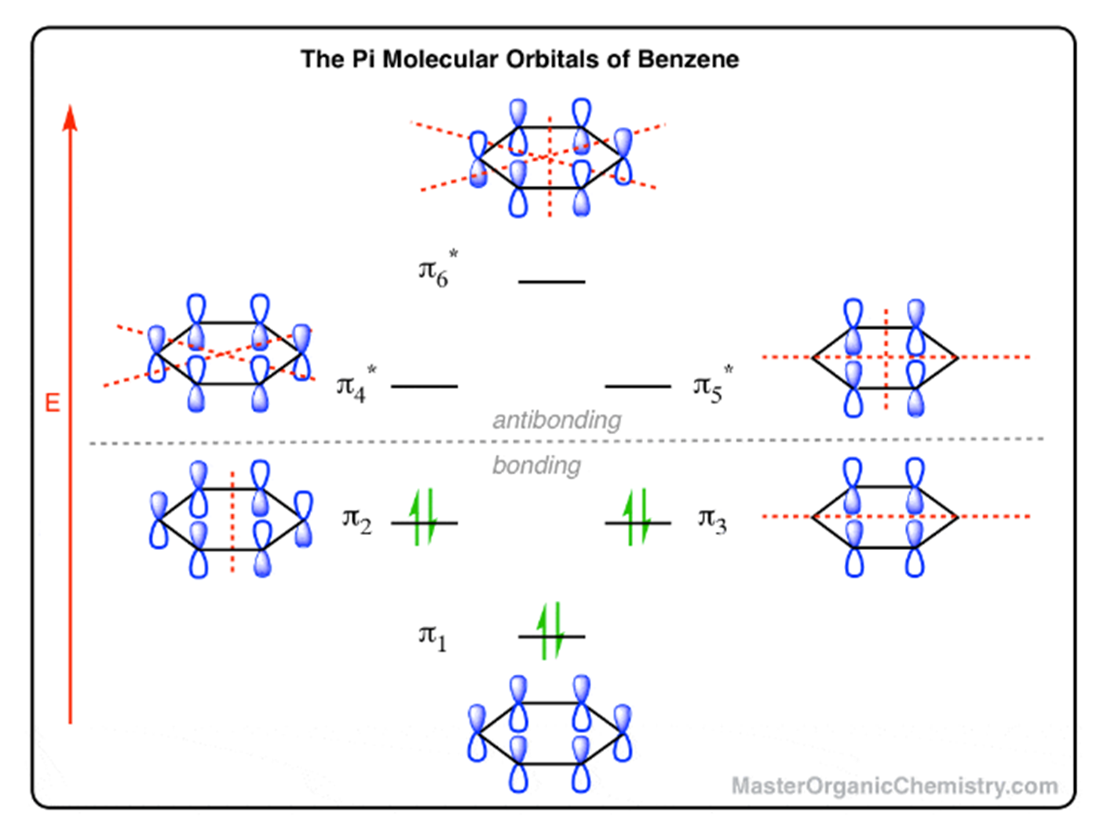

UNIT II
Modern Engineering materials

SEMICONDUCTORS:

Semiconductors are materials which have conductivity between conductors and insulators. Semiconductors can be compounds, such as gallium arsenide, or pure elements, such as germanium or silicon. Examples – Si, Ge, As etc.
Holes and electrons are charge carriers in semiconductors. They are accountable for the flow of current. Holes are the positively charged whereas electrons are the negatively charged particles. Both electrons and holes are equal in magnitude but opposite in polarity.
BAND THEORY OF SOLIDS:
- A useful way to visualize the difference between conductors, insulators and semiconductors is to plot the available energies for electrons in the materials.
- 2 Instead of having discrete energies as in the case of free atoms, the available energy states form bands.
- The valence band is the highest range of electron energies in which electrons are normally present at absolute zero temperature, while the conduction band is the lowest range of vacant electronic states.
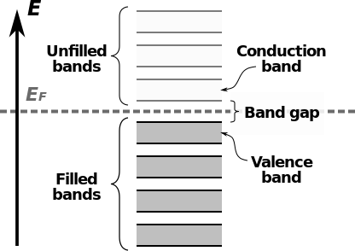
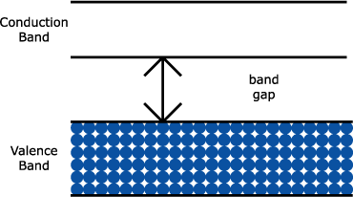
- The conduction band is the band of orbitals that are high in energy and are generally empty. In reference to conductivity in semiconductors, it is the band that accepts the electrons from the valence band.

ENERGY GAPS IN SEMICONDUCTORS:
Semiconductors have a finite but small bandgap (<3 eV). Because of this, at room temperature some electrons from valence band can acquire enough energy to to cross the energy gap and enter the conduction band. Hence, resistivity of semiconductors is not high as insulators
Q. WHAT IS A SEMICONDUCTOR? WHAT ARE INTRINSIC AND EXTRINSIC SEMICONDUCTORS?

A semiconductor is a substance, usually a solid chemical element or compound that can conduct electricity under some conditions but not others, making it a good medium for the control of electrical current.
It has almost filled valence band, empty conduction band and very narrow energy gap i.e., of the order of 1 eV. Energy gap of Silicon (Si) and Germanium (Ge) are 1.0 and 0.7 eV respectively. Consequently Si and Ge are semiconductors.

TYPES OF SEMICONDUCTORS:

Semiconductors can be classified as follows:
- Intrinsic Semiconductor
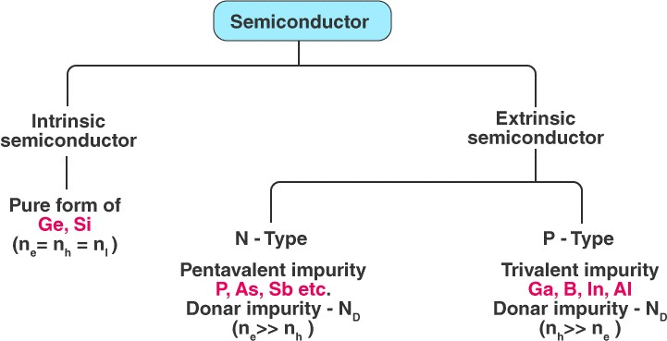
- Extrinsic Semiconductor

1.INTRINSIC SEMICONDUCTOR:

- Semiconductor in pure form is called Intrinsic Semiconductor.
- An intrinsic type of semiconductor material is made to be very pure chemically. It is made up of only a single type of element.
- Germanium (Ge) and silicon (Si) are the most common types of intrinsic semiconductor elements. They have four valence electrons (tetravalent). They are bound to the atom by a covalent bond at absolute zero temperature.
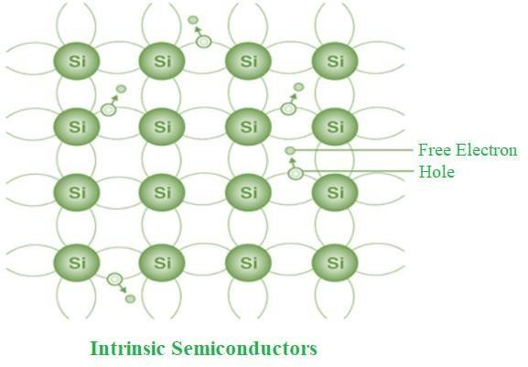

2.EXTRINSIC SEMICONDUCTOR:

- The conductivity of semiconductors can be greatly improved by introducing a small number of suitable replacement atoms called IMPURITIES.
- The process of adding impurity atoms to the pure semiconductor is called DOPING. Usually, only 1 atom in 10⁷ is replaced by a dopant atom in the doped semiconductor.
- An Extrinsic Semiconductor can be further classified into types:

P-type Semiconductor
  - N-type Semiconductor

P-Type Semiconductor:

- P-type semiconductor is formed due to the doping of III group elements i.e. Boron, Aluminium, Thallium, to a single crystal of silicon .These are also known as Trivalent semi-conductors.
- A P-type semiconductor is positive type semiconductor it means it deficiency of 1 electron is required.
- In P-type semiconductor majority charge carries are holes and minority charge carries are electrons.

N-Type Semiconductor:

- N-type semiconductor is formed due to doping of Group 5thelements i.e Nitrogen, Phosphorus, Arsenic, Antimony, and Bismuth to a single crystal of silicon. These are also knownpentavalent semiconductor.
- N-type semiconductor is negative type semi-conductor it means excess of 1 electron is required.
- In N-type semiconductor majority charge carries are Electrons and minority charge carries are holes.

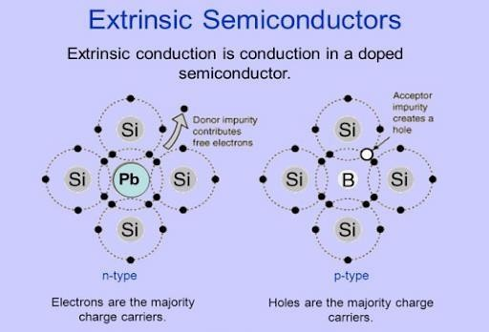

SEMICONDUCTORS PROPERTIES:

- Semiconductors act like insulators at zero Kelvin. On increasing the temperature, they work as conductors.
- Due to their exceptional electrical properties, semiconductors can be modified by doping to make semiconductor devices suitable for energy conversion, switches and amplifiers.
- Lesser power losses.
- Semiconductors are smaller in size and possess less weight.
- Their resistivity is higher than conductors but lesser than insulators.
- The resistance of semiconductor materials decreases with an increase in temperature and vice-versa.

Applications of Semiconductors:
- CPUs that operate personal computers are also made with semiconductors.
- Many digital consumer products in everyday life such as mobile phones / smartphones, digital cameras, televisions, washing machines, refrigerators and LED bulbs also use semiconductors.
- Transistors (a semiconductor) are major elements in electronic components, such as microprocessors.
- Semiconductors are used in building logic gates and various forms of digital circuits.
- Temperature sensors are made with semiconductor devices.
- They are used in 3D printing machines.
- Used in microchips and self-driving cars.
- Used in calculators, solar plates, computers and other electronic devices.

Q. WRITE A NOTE ON SUPER CONDUCTORS?

- Superconductors and superconducting materials are metals, ceramics, organic materials, or heavily doped semiconductors that conduct electricity without resistance.
- 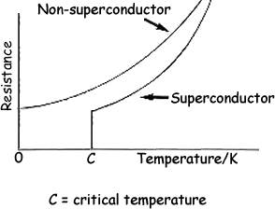
- Superconducting materials can transport electrons with no resistance, and hence release no heat, sound, or other energy forms. Superconductivity occurs at a specific material's critical temperature (T_{c}). As temperature decreases, a superconducting material's resistance gradually decreases until it reaches critical temperature. At this point resistance drops off, often to zero, as shown in the graph at right.

TYPES OF SUPERCONDUCTORS
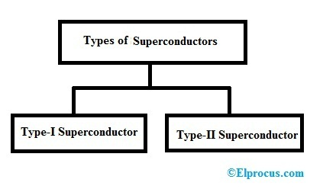
TYPE I SUPERCONDUCTOR | TYPE II SUPERCONDUCTOR
1. They exhibit complete Meissner effect . | 1. They exhibit partial Meissner effect.
2. These are perfect diamagnetics. | 2. These are not perfect diamagnetics.
3. These are known as soft superconductors. | 3. These are known as hard superconductors.
4. They have only one critical magnetic field. | 4. They have two critical magnetic fields.
5. These materials undergo a sharp transition from the superconducting state of the normal state at the critical magnetic field. | 5. These materials undergoes a gradual transition from the superconducting state to the normal state between the two critical magnetic fields.
6. The highest value of critical magnetic field is 0.1 wb/. | 6. The upper critical field can be of the order of 50 wb/ .
7. Applications are very limited. | 7. They are used to generate very high magnetic field.
8. Examples:- lead, tin, mercury , etc. | 8.Examples:- alloys like Nb-Sn, Nb-Ti, Nb- Zr, etc.

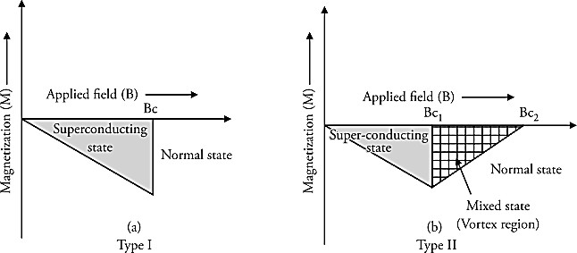

PROPERTIES OF SUPERCONDUCTORS:
Property 1: Critical temperature/Transition temperature
- The temperature below which the material changes from conductors to superconductors is called critical temperature or transition temperature. The transition from conductors to superconductors is sudden and complete.
Property 2: Zero Electric Resistance/Infinite Conductivity
- In the superconducting state, the material has zero resistance. When the temperature of the material is reduced below the critical temperature, its resistance suddenly reduces to zero. Mercury is an example of a superconductor that shows zero resistance below 4 kelvin.
Property 3: Expulsion of Magnetic Field
- Below the critical temperature, superconductors do not allow the magnetic field to penetrate inside it. This phenomenon is called Meisser Effect.
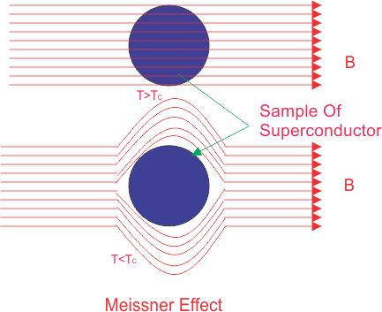
Property 4: Critical Magnetic Field
- The certain value of the magnetic field beyond which the superconductors return to conducting state is called the critical magnetic field. The value of the critical magnetic field is inversely proportional to the temperature. As the temperature increases, the value of the critical magnetic field decreases.

Applications of superconductors:

- Semiconductors are extensively used in the manufacturing of electronic devices like transistors, diodes, ICs, etc.
- Superconductors are used in manufacturing high-speed connections in computer ICs, making superconducting coils, MRIs, etc.
- Superconductors are used in particle accelerators, generators, transportation, computing, electric motors, medical, power transmission, etc.
- Superconductors are primarily employed for creating powerful electromagnets in MRI scanners.
- These conductors are used to transmit power for long distances.
- They are used in memory or storage elements.

Q. WHAT ARE SUPERCAPACITORS AND EXPLAIN IT?
- The electrodes of a capacitor are made up of a metallic conductor.
- Super capacitor consists of activated carbon coated electrodes.
- The electrical energy in a capacitor is stored electrostatically only.
- A super capacitor stores electrical energy either electrostatically or electrochemically or hybrid.
- Super capacitors are a type of an electrochemical energy storage system which have great power density and specific capacitance.
- These systems have the ability to efficiently release energy with a high density over a relatively short time.

Parameters | Capacitor | Supercapacitor
Discharge Time | Seconds to hours | Minutes
Examples | Aluminium electrolytic, Tantalum, Ceramic | Activated carbon, Graphene, Pseudocapacitors
Applications | Filters, timing circuits | Memory backup, cameras, laser printers, EVs

Examples:
- Electric cars.
- Wind turbines.
- Photographic flash.
- Flywheel in machines.
- MP3 players.
- Regenerative braking in the automotive industry.
- Static memories (SRAM)
- Industrial electrical motors.

Super capacitors are classified into three types:
- Electrostatic double-layer capacitors.
- Pseudo-capacitors.
- Hybrid capacitors.

Electrostatic Double Layer Capacitors:

- Electrostatic Double Layer Capacitors comprises two electrodes, a separator, and an electrolyte.
- Electrolyte is a mixture comprising positive and negative ions dissolved in water.
- The two electrodes are separated from each other through a separator.
- The super capacitors use carbon electrodes with much higher electrostatic double-layer capacitance.
- The separation of charge in electrostatic double-layer capacitors is much less than in a conventional capacitor which ranges from 0.3–0.8 nm

2.Pseudo Capacitors:

- Pseudo Capacitors are also referred to as electrochemical pseudo-capacitors.
- They make use of metal oxide or conducting polymer electrodes that have a high amount of electrochemical pseudo capacitance.
- They store electrical energy by electron charge transfer between electrode and electrolyte.
- It is done through the oxidation and reduction reaction commonly known as a redox reaction.

3.Hybrid Capacitors:

- Hybrid Capacitors are made by using the techniques of double-layer capacitors and pseudo-capacitors.
- In these capacitors, electrodes with different characteristics are used.
- One electrode has the capacity to display electrostatic capacitance and the other electrode showcases electrochemical capacitance.
- An example of a hybrid capacitor is the lithium-ion capacitor

Applications of Supercapacitor:
- Electric vehicles
- Windmills
- Flywheel in machines
- MP3 players
- Camera flash
- Automotive industry regenerative braking
- Industrial electrical motors and static memory (SRAM)s

NANOCHEMISTRY:
Nanochemistry is the science of tools, technologies, and methodologies for chemical synthesis, analysis, and biochemical diagnostics, performed in nanolitre to femolitre domains .
NANOPARTICLES:
Nanoparticles are the particles within the size ranging from 1-50 nm.
NANOMATERIALS:
Nanomaterials are the materials having components within size less than 100 nm at least in one dimension.
Materials can be produced in three dimensions:-
- One Dimension
- Two Dimension
- Three Dimension
- NANO SCALE IN ONE DIMENSION:
Nano Materials in one dimensional are layers like thin films or surface coatings which are developed and used for decades in fields such as electric device manufacture chemically and engineering. One- dimensional nanostructures offer unique opportunities to control the density of states of semiconductors , and in turn their electronic and optical properties.
- NANO SCALE IN TWO DIMENSION:
NanoMaterials in two dimensions are tubes like nanotubes and nanowires. Nanowires are considered as building blocks for electronics, phonotics, sensors and energy applications. Nanowires allow the growth of axial heterostructures without the constrains of lattice mismatch.
- NANO SCALE IN THREE DIMENSIONAL:
Nanomaterials in three dimensions are particles like precipitates, colloids and quantum dots.

Q. WHAT ARE CARBON NANO TUBES? EXPLAIN THEIR TYPES.

Carbon nano tubes (CNTs):
- CNTs are made up of carbon and look like a long, thin cylinders.
- In CNT, each carbon atom is covalently bonded to three other nearby carbon atoms.
- CNTs are very big molecules having very small size, shape and rare physical properties.
- CNT is one of the physical forms (allotropes) of carbon and others are diamond, graphite fullerenes etc.
- Length to diameter ratio of a CNT is greater than 100,000.
- CNT is formed, when hexagonal graphene sheet is turned around into a cylinder and its edges joined
- So the CNTs are longer tubes of graphite sheet.

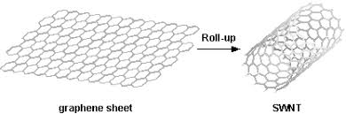

• Types of CNTs:
- There are two types of CNTs depends on their arrangement.
- Single walled nano tubes (SWNTs)
- Multi walled nano tubes (MWNTs)

• Single walled nano tubes (SWNTs):
- SWNT is formed, when single one atom thick graphene sheet is turned around into a cylinder and its edges joined.
- SWNTs have a diameter of 1 nm.
- The length of SWNT is many millions times of its diameter.
- SWNT show electrical conductivity.
- It is used to make field affect transistors (FETs).
- There are three types of SWNTs based on the arrangement of single one atom thick graphene sheet.
- Armchair
- Zigzag
- Chiral
- Graphene sheet is represented by a pair of indices (n,m) called Chiral vector. Where n and m are number of unit vectors along two directions in the hexagonal crystal lattice of graphene.
- If n = m, the nano tubes are called “armchair”.
- If m = 0, the nano tubes are called “zigzag”.
- Otherwise, they are called “Chiral”.
- It has a bend shape around the nano tube

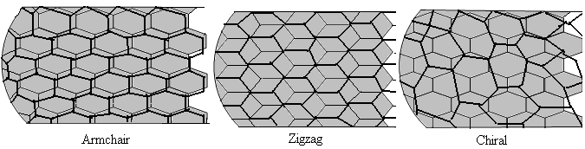

• Multi walled nano tubes (MWNTs):

- MWNT is formed, when more than two one atom thick graphene sheets are turned around into a cylinder and its edges joined.
- These are concentric tubes of graphene.
- The distance between graphene layers of MWNT is ≈ 3.3 A0.
- New function groups are inserted on the surface of DWNTs to add new properties to it.
- This type of DWNTs shows both metallic and semiconducting properties.
- It the Russian doll model, sheets of graphene are arranged in concentric cylinders, for example: a large (0, 10) SWNT in a small (0, 8) SWNT.
- In the parchment (means animal skin) model, a single sheet of graphene is turned around itself, like a roll of news paper.

Q. EXPLAIN THE PROPERTIES AND APPLICATIONS OF CARBON NANO TUBES OR NANO MATERIALS.
Properties of CNTs (or Nano materials):
1.Mechanical properties:
- Strength:
- The strength of SP2 C-C bonds gives CNTs a special type of properties.
- CNTs are strongest and stiffest materials than diamond in terms of tensile
(extension) strength and elastic modulus.
- This strength is due to the SP2 bonds formed between the carbon atoms.
- It has low density than diamond.
- Hardness:
- CNTs have highest elastic modulus and harder than diamond.
- CNTs can withstand damage from physical forces.
- Young’s modulus of MWNTs is 1200 G Pa where as for diamond it is 600 G Pa.
2.Electrical properties:
- CNTs are metallic or semiconducting depending on the structure of graphene sheet.
For a given (n,m) nano tube,
- If n=m, the nano tube is metallic.
- If n-m is multiple of 3, then the nano tube is semiconducting.
- Otherwise the nano tube is moderate semiconductor.

3.Vibration properties:
Atoms in CNTs are continuously vibrating outwards and forwards and they have two modes of vibrations.
- A1g mode: It has in and out movements.
- E2g mode: It has movement between Sphere and ellipse.

Engineering applications of CNTs:
Uses in fuel cells:
- The SWNTs are used to store hydrogen.
- The SWNTs are used to make fuel cell electrodes.
- CNTs are used as catalysts in fuel cell.
- Pt/CNT electrodes produce more electricity than Pt/CB (carbon black) electrodes.
Uses in catalysis:
- When catalyst having CNTs used, the reaction takes place with a medium rate and gives the required product.
- CNTs are used as both catalyst and catalyst supportive materials.
- CNTs containing nitrogen are used as cathodes in highly alkaline solution.
- Oxidizable CNTs containing phosphorous are used in oxidative dehydrogenation of butane and butadiene.
- Some chemical reactions are also done inside the nano tubes. For example:
- Reduction of Nickel oxide (NiO) to Ni.
- Reduction of AlCl₃ to Al.
Uses in medicine:
- Drug molecules joined to the CNTs are used to leave the drug molecule at the required part of the body; for testing and control of diseases.
- This is very useful in cancer treatment.
- CNTs are used to check the presence of DNA.
Q. DISCUSS THE PREPARATION, PROPERTIES AND APPLICATIONS OF FULLERENES.
Fullerenes:
- Fullerene is the third newly discovered physical form (allotrope) of carbon.
- The structure of C-60 fullerene looks like a circular building (dome) constructed by Buminster Fuller.
- It is also called as Buckminster fullerene.
- This chemical compound is named as fullerene by considering the hard work of Buckminster fuller in the construction of the circular building (Dome).
- The structure of C-60 fullerene:
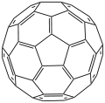

• Types of fullerenes:
- There are three types
- Spherical fullerenes: They look like a soccer ball and many times called as Bucky balls.
- Cylindrical fullerenes: These are called CNTs of Bucky tubes.
- Planar fullerenes: Graphene is an example of planar fullerene sheet.
• Preparation:
- Fullerenes are made by vaporizing a graphite rod in a helium atmosphere.
- Mixture of fullerenes like C-60, C-70 etc. is formed.
- These are separated by solvent extraction.
- C-60 is gotten from this mixture by column chromatography using alumina and hexane.
• Structure:
- Fullerenes have closed cage structure like the structure of C-60 and it has chemical formula Cn.
- Every fullerene contains (constant number of) 12 pentagons and changeable number of hexagons.
- C-60 fullerene contains even number of SP2 carbon atoms and its crystals are spherical in shape.
- Each atom is connected to its nearby carbon atoms through covalent bonds to form polyhedron cage structure.
- The C-60 molecule has bent icosohedron structure.
- An icosohedron is a polygon with 60 vertices and 32 faces, 12 of which are pentagonal and 20 hexagonal.
• Properties:
o Fullerene is different type of molecule.
o C-60 is brown to black color solid.
- It is soluble in aromatic hydrocarbons.
- It dissolves in benzene to form purplish red solution.
- It is very tough and it can be pushed against a tough surface without damaging it.
- It is stable up to 6000C and it becomes liquid under vacuum at 6000C.
- It has highest tensile (extension) strength.
- It has highest packing density.
- It can be pressed to lose 30% of its volume without spoiling its cage like structure.
- Engineering applications:
- Fullerenes are used to
- Carry charge in batteries
- Make photovoltaic cells
- Make lubricants
- Make protective covering in wars
- Stop cell damages in human body
- Make catalyst that is used in hydrogenation and dealkylations.
- Make alkali metal fullerides that are superconductors

Q. DISCUSS THE PREPARATION, PROPERTIES AND APPLICATIONS OF GRAPHENE

- Graphene is a crystalline allotrope of carbon with two-dimensional, atomic scale, hexagonal pattern. Here each carbon atom forms four bonds, three s bonds (sp2 hybridized) with its three neighbours and one p bond oriented out of plane. It is the basic structural element of other allotropes like graphite, fullerene, nanotubes, Nano cones, etc. hence called mother of all carbon nanomaterial‘s.

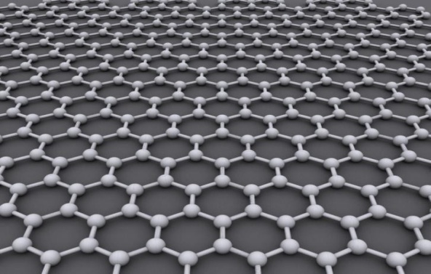

Graphene Preparation:

- There are two key graphene synthesis routes, and they can be categorized as (i) top-down and (ii) bottom-up techniques and are schematically represented.
- In top-down methods, bulk material such as graphite is transformed into its smallest constituents to produce graphene.
- In the bottom-up synthesis route, graphene is produced through the decomposition of carbon-containing precursors (both gaseous and liquid) followed by the formation of a hexagonal structure of graphene.

Chemical Reduction Process:

- Chemical oxidation of graphite to graphene oxide followed by the reduction process is the commonly used method for mass scale production of graphene or reduced graphene oxide (RGO).
- Among the large number of chemical reducing agents used to prepare RGO or graphene, the most efficient reductant is hydrazine.
- It is toxic in nature and harmful to the environment, thus it is in high demand to use green reductants for RGO synthesis.
- We understand that due to high demand of graphene/graphene oxide/reduced graphene oxide recently and which is expected to be more in future, green synthesis methods are extremely important.

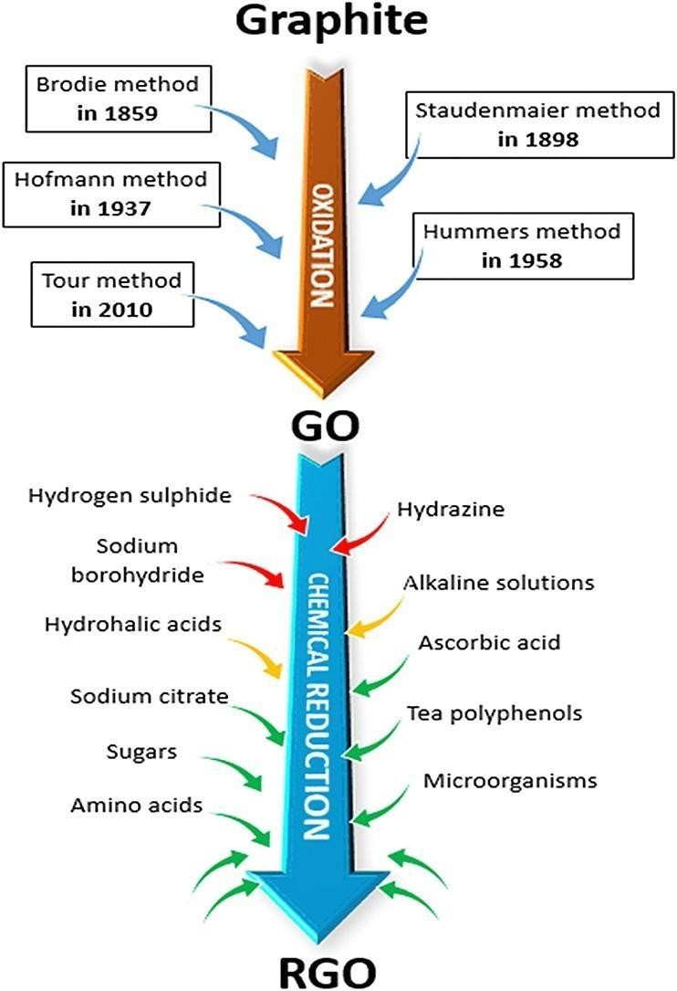

Properties:

- It is nearly transparent.
- It is 200 times stronger than steel by weight due to its tightly packed carbon atoms.
- It conducts heat and electricity with great efficiency due to presence of p electrons. Nowadays.
- It is commonly used in semiconductors, batteries, electronics, composite industries, and many more.
- Biological Engineering: Bioengineering will certainly be a field in which graphene will become a vital part of in the future; though some obstacles need to be overcome before it can be used.

Applications
- Optical Electronics.
- Ultra-filtration.
- Composite Materials.
- Photovoltaic Cells.
- Energy Storage.

IMPORTANT QUESTIONS

- Describe about the Semiconductors and its Applications?
- Draw and explain the Band diagram in solids with the help of example?
- How the p-n junction diode working as a rectifier? explain
- How the p-n junction diode working as transistors? explain
- Explain about the Super conductors with examples?
- Classification of superconductors?
- Mention the applications of superconductors?
- Explain about the properties of super conductors?
- Discuss the Super capacitors? Classification of Super capacitors? Mention the applications of Super capacitor?
- Explain the Properties of Super capacitors?
- Explain about the Nano materials, classification, properties and applications?
- Write a short note on Fullerenes, properties and Applications?
- Write a short note on carbon Nano tubes, properties and Applications?
- Write a short note on Graphines nanoparticles, properties and Applications?

UNIT III

Electrochemistry and Applications
The branch of chemistry, which deals with the chemical changes caused by the passage of electric current; and production of electrical energy due to chemical changes, is known as electrochemistry.

Conductance:
The passage of electric current through a substance is called electrical conductance. Electrical conductivity is due to movement of electrons or ions.
Conductor:
A substance which allows the passage of electric current through it is called a conductor.

Ex: All metals, fused salts, acids and alkalis.

Based on electrical conductivity, the materials are classified into two types.

- Metallic or electronic conductors 2.Electrolytic conductors
Metallic or Electronic conductors:

Metallic conductors conduct electricity by the movement of electrons from one end to another end of the metal.These conductors are further sub classified into 3 types

a. Good conductor b.Semi-conductor c.Non- conductor or insulator

Good conductor:
It is a substance, which conducts electricity fully andfreely.
Ex: metals like copper, aluminium and iron

Semi-conductor:
It is substance, which partially conducts electricity. The

conductivity depends on temperature. Ex: silicon, germanium

Insulators:
The substance which resists the flow of electric current through them are called insulators. They do not have free electrons or freely moving charged particles.
Ex: plastics, rubber, wood, wax, wool, glass, etc.
Electrolytic conductor:

It is a substance, which in aqueous solution or in molten state liberates ions and allows electric current to pass through it.

Depending on the extent of dissociation, electrolytic conductors are classified into 3 types

Strong electrolytes: strong electrolytes are completely dissociated into ion salt all concentrations.

Ex;NaCl, HCl, and NaOH

Weak electrolyte: weak electrolytes dissociate only to a small extent even at very high dilutions.

Ex: CH₃COOH and NH₄OH

Non-electrolytes: Non-electrolytes do not dissociate into ions even at low dilutions.
Ex: Glucose and sugar.

Resistance (R):The tendency of a material to stop the flow of current through it is known as resistance. It is measured in ohms (Ω).

Cell Terminology
- Current : Flow of electrons through a conductor
- Electrode : Electrode is a material (rod, bar, strip) which conducts electrons
- Anode : Electrode at which oxidation occurs
- Cathode : Electrode at which reduction occurs
- Electrolyte : Water soluble substance forming ions in solution and conducts electric current
- Anode compartment: Compartment of the cell in which the oxidation half reaction occurs. Contains the anode
- Cathode compartment: Compartment of the cell in which the reduction half reaction occurs. Contains the cathode
- Half – cell: Part of the cell, which contains an electrolyte dipped in an electrolyte. If oxidation occurs in this half, then it is called the oxidation half cell. If reduction occurs at the cell, it is called the reduction half cell
- Cell: Device consisting of two half cell. The two half cells are connected by a conductor

Electrode potential:-
The tendency of metal atoms to go into solution is called electrode potential.
eg:- M (metal) immersed in solution of its own ions (M^{n+}), the following changes takes place
- M^{n+} ions collide each other with M leads to no change.
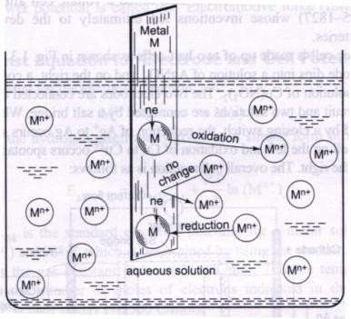
- M^{n+} ions collide with M and gains electrons.
- M lose electrons and forms M^{n+}.
The electrode develops a small negative charge potential with respect to the solution.
Characteristics:
  - If the tendency of M to oxidise into M^{n+} ions is high—no. of M^{n+} ions willbe more.
  - If the tendency of M^{n+} ions to reduce into M is high—no. of M^{n+} ions will be less.

Q. Drive the construction of Electrochemical Cell (Galvanic Cell)
An electrochemical cell is also known as galvanic cell or voltaic cell. A redox reaction takes place in such cells.
- It consists of two half-cells.
- The left hand half-cell contains a zinc metal electrode dipped in ZnSo₄ solution.
- The half-cell on the right hand side consists of Cu metal electrode in a solution of CuSo₄.
- A salt bridge that prevents the mechanical mixing of the solution joins the half-cells.
When the zinc and copper electrodes are joined by a wire the following observation are made.
- There is flow of electric current through the external circuit.
- The Zn rod loses its mass while copper rod gains in the mass.
- The concentration of ZnSo₄solution increases while the concentration of CuSo₄ solution decreases.
- The solutions in both the compartments remain electrically neutral.

During the passages of electric current through external circuit, electrons flow from zinc electrode to the copper electrode. At the zinc electrode, zinc metal is oxidized to zinc ions, which go into the solution. The electrons released at the electrode travel through the external circuit to the copper electrode where they are used in the reduction of Cu²⁺ ions to metallic copper which is deposited on the electrode.

Cell Reaction
Zn Zn²⁺ + 2e (Oxidation So anode)
Cu²⁺ + 2e Cu (Reduction So cathode)
Net reaction Zn + Cu²⁺ Zn²⁺ + Cu
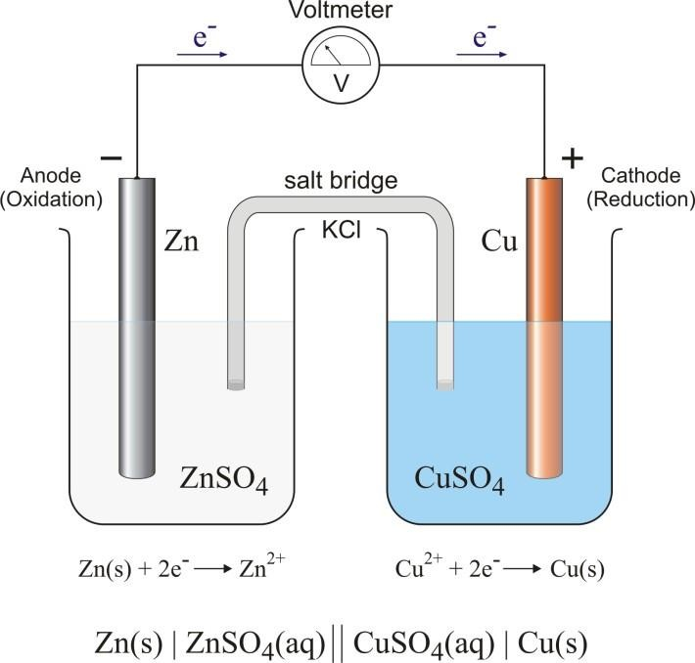
At the zinc rod, oxidation occurs. So it is the anode of the cell and negatively charged.
Electrode Sign : The sign of the anode and cathode in the voltaic or galvanic cells are opposite to those in the electrolytic cells.

Applications of Electrochemical Cells:

- Electrochemical cells are used in torches, digital watches, military applications, corrosion protection, etc.
- The production of high-purity lead, zinc, aluminium, and copper involves the use of electrolytic cells. They use it to analyse a solution for trace amounts of metal ions.
- Electrolytic cells are used in the electro refining of many non-ferrous metals.
- The production of high-purity lead, zinc, aluminium, and copper involves the use of electrolytic cells.

Q. Derive Nernst equation for an electrochemical cell.

The Nernst equation is often used to calculate the cell potential of an electrochemical cell at any given temperature, pressure, and reactant concentration. The equation was introduced by a German chemist, Walther Hermann Nernst.
According to the theory of thermodynamics, the reaction quotient, Gibbs free energy, and standard Gibbs free energy are related as:

ΔG=ΔG₀+RTlnQ

Where Q is the reaction quotient,
R is the universal gas constant, and;
T= Temperature in Kelvin.
For any cell reaction, Gibbs free energy is related to standard electrode potential as follows:

ΔG=–nFE

Where ΔG= Gibbs free energy,
n is the number of electrons transferred in the reaction,
F is Faraday’s constant (96,500C/mol)(96,500C/mol) and
E is the cell potential.
Under standard conditions, Eqn can be written as,
ΔG₀=–nFE₀

Where, ΔG₀ is standard Gibbs free energy
E₀ is standard cell potential
The reaction is spontaneous; when E₀ is positive, and the reaction is non-spontaneous when E₀ is negative.
Incorporating the value of ΔG and ΔG₀
we get:

–nFE=–nFE₀+RTlnQ

–nFE=–nFE₀+RTlnQ
Dividing both sides by nF we get-

E=E₀–(RT/nF)lnQ
E=E₀–(2.303RT/nF)log₁₀Q

At standard temperature T=298K, R is the gas constant = 8.314 J/K Mole

E=E₀–(0.0592/n)log₁₀Q

The above equation indicates that the electrical potential of a cell depends upon the reaction quotient Q of the reaction. As the reaction proceeds, reactants are consumed; thus, the concentration of reactants decreases and the concentration of products increases. Consequently, cell potential gradually decreases until the reaction is at equilibrium.
Applications of Nernst Equation
Various application of the Nernst Equation is,
- Electrochemistry: The Nernst equation is commonly used in electrochemistry to calculate the potential of an electrode in a cell and to determine the concentration of reactants and products in a reaction.
- Biochemistry: The Nernst equation can be used in biochemistry to calculate the potential of ion channels in biological membranes and to understand the transport of ions across membranes.
- Analytical Chemistry: The Nernst equation can be used in analytical chemistry to calculate the concentration of ions in a solution, such as the concentration of hydrogen ions in an acid-base titration.
Limitations of Nernst Equation
The Limitations of Nernst Equation are discussed below,
- Nernst equation is based on the assumption of ideal conditions, such as constant temperature and pressure, which may not always be the case in real-world applications.
- Nernst equation assumes that the electrode potential remains constant, which is not always the case in practical applications due to the effects of electrode polarization.
- Nernst equation is only applicable to reactions involving a limited number of ions and is not applicable to reactions involving complex species or to reactions involving multiple electron transfer processes.

P1.What is the Cell Potential of the electrochemical cell in which the cell reaction is: Pb²⁺ + Cd → Pb + Cd²⁺? Given that Eº_{cell} = 0.277 volts, temperature = 25ºC, [Cd²⁺] = 0.02 M, and [Pb²⁺] = 0.2 M.

Solution
Since the temperature is equal to 25ºC, the Nernst equation can be written as follows:
E_{cell} = E⁰_{cell} – (0.0592/n) log₁₀Q
Here, two moles of electrons are transferred in the reaction. Therefore, n = 2. The reaction quotient (Q) is given by [Cd²⁺]/[Pb²⁺] = (0.02M)/(0.2M) = 0.1.
The equation can now be rewritten as:
E_{cell} = 0.277 – (0.0592/2) × log₁₀(0.1)
E_{cell} = 0.277 – (0.0296)(-1) = 0.3066 Volts
Thus, the cell potential of this electrochemical cell at a temperature of 25ºC is 0.3066 volts.
P2.The Cu²⁺ ion concentration in a copper-silver electrochemical cell is 0.1 M. If Eº(Ag⁺/Ag) = 0.8 V, Eº(Cu²⁺/Cu) = 0.34V, and Cell potential (at 25ºC) = 0.422 V. Find the silver ion concentration.

Solution
Here, the silver electrode acts as a cathode, whereas the copper electrode serves as the anode. This is because the standard electrode potential of the silver electrode is greater than that of the copper electrode. The standard electrode potential of the cell can now be calculated, as shown below:
Eº_{cell} = Eº_{cathode} – Eº_{anode} = 0.8V – 0.34V = 0.46V
Since the charge on the copper ion is +2 and the charge on the silver ion is +1, the balanced cell reaction is:
2Ag⁺ + Cu → 2Ag + Cu²⁺
Since two electrons are transferred in the cell reaction, n = 2, the Nernst equation for this electrochemical cell can be written as follows:
E_{cell} = E⁰_{cell} – (0.0592/2) × log(0.1/[Ag⁺]²)
0.422V = 0.46 – 0.0296 × (-1 – 2log[Ag⁺])
Therefore, -2log[Ag⁺] = 1.283 + 1 = 2.283
Or, log[Ag⁺] = -1.141
[Ag⁺] = antilog(-1.141) = 0.0722 M

Q.WHAT IS CONDUCTIVITY?
- The ability of a substance to provide ease in the flow of electric current or charge through it is called conductivity.
- It is denoted by the Greek letter sigma (σ).
- Mathematically, the conductivity of a material is expressed as the reciprocal of its resistivity, i.e.,

Conductivity,σ =1/Resistivity(ρ)⋅⋅

- The conductivity is also known as specific conductance. The conductivity is measured in Siemens per meter (S/m) or mho per meter (Ω⁻¹m⁻¹).

Types of conductivity Electrical Conductivity (EC):

1. Thermal Conductivity (TC):

- Thermal conductivity, the ability of a substance to conduct heat or move heat from one location to another without the movement of the material conducting the heat.
- Thermal conductivity is measured in watts per meter kelvin (W/mK).

2. Ionic Conductivity (IC):
- Ionic conductivity is electrical conductivity due to the motion of ionic charge. Elementary science introduces this phenomenon as a property of liquid electrolyte solutions.
Conductivity examples:
Metals like copper, iron, gold, aluminum, and silver are the best materials for conducting electricity.

Applications of Conductivity:

- Conductivity is used to monitor both the concentration of the CIP solution, typically sodium hydroxide, and the completeness of the rinse.
- Interface detection. If two liquids have appreciably different conductivity, a conductivity sensor can detect the interface between them.
- Pouring of hot tea in a cup will make the cup of the also warm because of the heat transfer from tea to the cup.
- Transfer of heat from iron to shirt while pressing is also a good example. 4) Transfer of heat during cooking to the food.

Q.WHAT IS CONDUCTIVITY CELL ?
- Conductivity cells, also called conductivity electrodes or probes, are constructed with metal electrodes placed at a fixed distance in either glass or plastic body and surrounded by an outer tube.

- The distance between the electrodes divided by their surface area is known as cell constant.

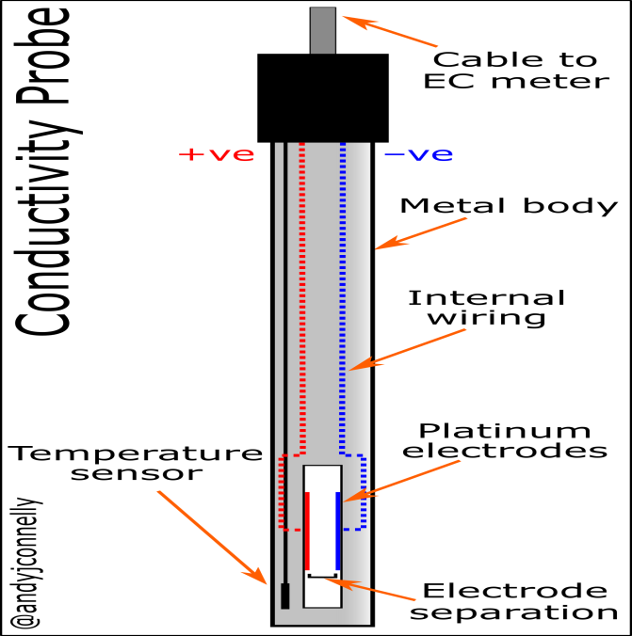

There are three types:

- TYPE-A conductivity cells.
- TYPE-B conductivity cells.
- TYPE-C conductivity cells.

Electrodes:

The sheets of platinum, each 1 cm wide, are fixed one to another.
Applications:
  - Conductometry analysis has numerous applications in fields such as chemistry, biochemistry, environmental science, and industrial processes.
  - It is used to determine the concentration of ions in solutions, monitor water quality, analyze the purity of substances, study chemical reactions, and assess the conductivity of electrolytes.

Q.Explain conductometric titration .

Principle
The principle of the conductometric titration process can be stated as follows – During a titration process, one ion is replaced with another and the difference in the ionic conductivities of these ions directly impacts the overall electrolytic conductivity of the solution.
It can also be observed that the ionic conductance values vary between cations and anions. Finally, the conductivity is also dependant upon the occurrence of a chemical reaction in the electrolytic solution.

Theory

The theory behind this type of titration states that the end-point corresponding to the titration process can be determined by means of conductivity measurement. For a neutralization reaction between an acid and a base, the addition of the base would lower conductivity of the solution initially. This is because the H+ ions would be replaced by the cationic part of the base.
After the equivalence point is reached, the concentration of the ionic entities will increase. This, in turn, increases the conductance of the solution. Therefore, two straight lines with opposite slopes will be obtained when the conductance values are plotted graphically. The point where these two lines intersect is the equivalence point.
Conductometry is a measurement of electrolytic conductivity

- The titration in which end point is determined by measuring change in conductance of solution upon addition of reagent is called conductometric titration.
- The conductance of a solution depends largely on the number of ions and their mobilities. Some examples of conductometric titrations are as given below.

Strong acid against strong base: (HCl against NaOH)

Consider the titration of strong acid (HCl) against strong base (NaOH). The acid is taken in conductivity vessel and alkali in burette. The conductance of HCl is due to presence of H⁺ and Cl¯ ions. As alkali is added, gradually H⁺ ions are replaced by slow moving Na⁺ ions as given below:
H⁺ + Cl¯ + Na⁺ + OH¯ Na⁺ + Cl¯ + H2O
Until the complete neutralization, conductance decreases on addition of NaOH. Any subsequent addition of alkali after end point will result in introduction of fast moving OH¯ ions. The conductance therefore increases on further addition of alkali. The variation of conductance is plotted against volume of alkali added, we get two straight lines meeting at point ‘B’ which represents end point of titration.

Conductance
A
C
B

Volume of alkali added

Weak acid against strong base: (CH3COOH against NaOH)

When acid is weak, conductance is low, on addition of strong base poorly conducting acid is converted into highly ionsed salt and hence conductance increases slowly up to the equivalence point. Beyond the equivalence point, addition of alkali causes sharp increase in conductance due to excess of hydroxide ions.
  - CH3COO⁻ + H⁺ + Na⁺ + OH¯  CH3COO⁻ + Na⁺ + H2O The graph is represented as:
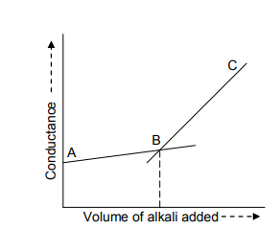

Strong acid against weak base: (HCl against NH4OH)
In this case conductance initially decreases due to the replacement of fast moving H⁺ ions by slow moving NH4+ ions.
H⁺ + Cl⁻ + NH4+ + OH¯  NH4+ + Cl⁻ + H2O
A
B
C

Volume of alkali added
Conductance

Beyond end point, further addition of weakly ionized NH4OH will not cause any appreciable change in conductance. The point of intersection of curves is the end point of titration.

Weak acid against weak base: (CH3COOH against NH4OH)

In this titration, conductance initially increases because of formation of salt (CH3COONH4) which is strong electrolyte. This increase continues till end point. Beyond end point, the conductance does not change appreciably.
  - CH3COO⁻ + H⁺ + NH4+ + OH¯  CH3COO⁻ + NH4+ + H2O
The graph is shown in fig.
B C
A

Volume of alkali added
Conductance

Precipitation titration: (AgNO3 against KCl)

The titration of silver nitrate against potassium chloride involves precipitate formation.
AgNO3 + KCl  KNO3 + AgCl ↓
Since mobility of Ag⁺ and K⁺ ions is nearly same, the conductance remains almost constant till the equivalence point. After equivalence point, the added KCl, increases the conductance rapidly as shown in graph given below.

Volume of KCl added

Volume of KCl added

Conductance

Advantages of conductometric titrations:
The conductometric titration has many advantages over ordinary titration:
- Small quantity of solutions is required for titrations.
- As end point is determined graphically, no special precautions are necessary.
- Indicator is not required, so conductometric titrations are used in titration of coloured and turbid solutions.
- Conductometric titrations are used for analysis of dilute solutions as well as for weak acids.
- Conductometric titrations can be applied to mixture of acids, precipitation & other types of titrations.
- Conductometric measurements give more accurate results.

Disadvantages of conductometric titrations:
The conductometric titration has following disadvantages:
🞄 High concentration of salt in the solution does not give accurate results.
🞄 Presence of another electrolytes other than the species to be analysed will not give accurate results.
🞄 Limited use for redox titration .

Applications of conductometric titrations:
The conductometric titration has following applications:
🞄 Pollution in water.
🞄 Quantitative analysis of compounds
🞄 Alkalinity of water.
🞄 Salinity of water.
🞄 Basicity of organic acids.
🞄 Deuterium ion concentration in water.
🞄 Solubility of sparingly soluble salts.

Q. WHAT IS POTENTIOMETRIC TITRATION.?
Potentiometric is the method to find the concentration of solute in a given solution by measuring the potential between two electrodes.
Potentiometric titrations:

In analytical chemistry, potentiometric titration is a technique similar to direct titration of a redox reaction.

Redox Titration:
This type of potentiometric titration involves an analyte and titrant that undergo a redox reaction. An example of this type of titration would be thetreatment of an iodine solution with a reducing agent which produces iodide ion (a starch indicator is used to get the endpoint).

Potentiometric Titration Method:

Principle:

Potentiometric principles state that the change in the potential difference between 2 electrodes of a cell is. It determines the analyte concentration by a change in the concentration of ions. Ans. Potentiometric titration is another term given to potentiometric.
Procedure:
- Potentiometric Titration is done via the usage of two electrodes – an indicator electrode and a reference electrode (generally a hydrogen electrode or a silver chloride electrode). One half-cell is formed with the indicator electrode and the ionsOf the analyte, which is generally an electrolyte solution. The other half-cell is formed by the reference electrode.

The overall cell potential can be calculated using the formula given by:

E cell = E ind –E ref + E sol

Where, the potential drop between the indicator and reference electrodes over the electrolyte solution is given by E _{cell}.

- The overall cell potential, E _{cell} is calculated in every interval where the titrant is measured and added. Now, a graph is plotted with the Potential difference on the Y-axis and the volume on the X-axis as shown below.
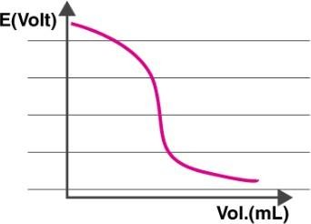

- It can be observed from the graph that the electric potential of the cell is dependent on the concentration of ions which are in contact with the indicator electrode. Therefore, the E _{cell} is measured with each addition of the titrant.

Applications

- Redox Titration: This type of potentiometric titration involves an analyte and titrant that undergo a redox reaction.
- An example of this type of titration would be the treatment of an iodine solution with a reducing agent which produces iodide ion (a starch indicator is used to get the endpoint).

Q.EXPLAIN THE ELECTROCHEMICAL SENSOR? EXPLAIN ITS TYPES

An electrochemical sensor, created in 1950, is a device that measures the concentration of analytes, preferably in a gaseous state, either by oxidation or reduction at an electrode and measuring the resulting out flowing current.
Examples:

Some examples include gas sensors, such as those used in homes to detect CO, heavy metal sensors for water quality analysis, and hydrocarbon, alcohol, and ketone sensors for measuring motor oil degradation.

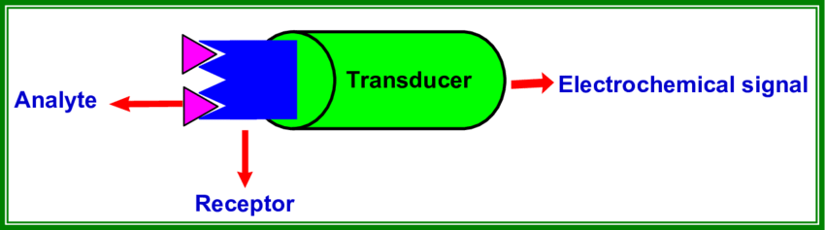

Principal:

- Electrochemical sensors work by reacting with the gas of interest and producing an electrical signal proportional to the gas concentration.
- Consisting of two electrodes (a working electrode and a counter electrode), the sensor operates by allowing charged molecules to pass through a thin layer of electrolyte.

Instrumentation:

- Electrochemical sensors are made up of three essential components: a receptor that binds the sample, the sample or analyte, and a transducer to convert the reaction into a measurable electrical signal.
- In the case of electrochemical sensors, the electrode acts as the transducer.

Working:

- Electrochemical sensors work by reacting with the gas of interest and producing an electrical signal proportional to the gas concentration.
- Consisting of two electrodes (a working electrode and a counter electrode), the sensor operates by allowing charged molecules to pass through a thin layer of electrolyte.
Applications:

Electrochemical sensors are very accurate and can measure oxygen levels down to the parts-per-million (ppm) level. This makes them a vital sensing technology for many different industries, including hospitals, factories, and environmental monitoring.

Types:

There are three main types of electrochemical sensors:
1. Potentiometric, 2.Amperometric 3. Conductmetric.
1.Potentiometric sensors:

- A potentiometric sensor is a type of chemical sensor that may be used to determine the analytical concentration of some components of the analyte gas or solution.
- These sensors measure the electrical potential of an electrode when no current is present.
- Potentiometric sensors mainly determine the analyte concentration by measuring the variation of potential difference between working and reference electrodes at different analyte concentrations.
- Ion-selective electrodes belong to such sensor. The typical example is pH meter. Examples:
- Potentiometric sensors mainly determine the analyte concentration by measuring the variation of potential difference between working and reference electrodes at different analyte concentrations.
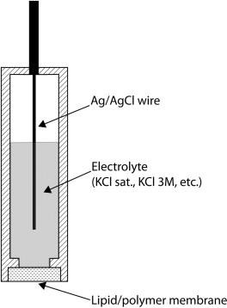
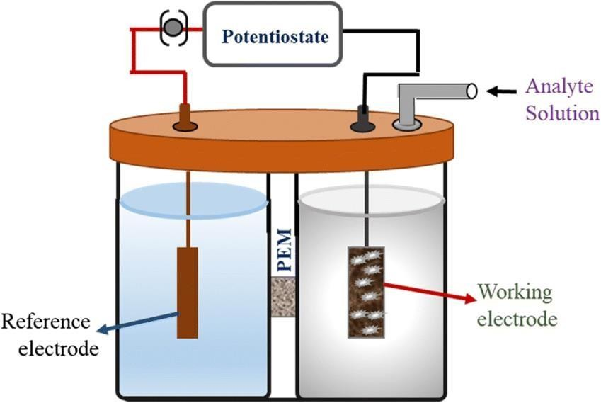
- Ion-selective electrodes belong to such sensor. The typical example is pH meter.
Principal:
Potentiometric sensors are based on polymeric membrane ion-selective electrodes (ISE) and ion-selective field effect transistors (ISFET), measuring the potential change at one electrode against another.

Instrumentation:

- A potentiometric sensor is a type of chemical sensor that may be used to determine the analytical concentration of some components of the analyte gas or solution.
- These sensors measure the electrical potential of an electrode when no current is present.

Working:

- The instrumentation used to perform potentiometric is straight forward, consisting of an indicator electrode, a reference electrode, and a potential measuring device.
- This simplicity makes potentiometric an inexpensive technique compared to atomic spectroscopy or ion chromatography.
Applications:

- Potentiometric-based analysis methods are highly important in the field of electrochemistry and are commonly used for the determination of different organic and inorganic ions in various areas such as process control and environmental, industrial, agricultural analysis and also medicinal drug analysis.

2. Amperometric sensors:

Principle:

The principle of amperometric sensor is based on measuring current generated by enzymatic or bio affinity reaction at the electrode surface, at a constant working potential with respect to the reference electrode.
Instrumentation:

In the amperometric sensors, a signal is generated by a voltage applied across the oxide- ion conducting electrolyte. The generated oxide-ion current is determined by the availability of the oxygen-containing species in the gaseous atmosphere.
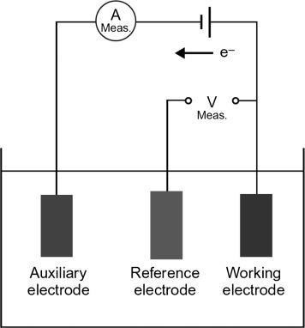
Working:

- Amperometric sensors measure current response to detect the concentration of an analyte at a fixed potential.
- A simple form of amperometric measurement is single-potential amperometry or DC amperometry. A voltage is applied between two electrodes during measurement.

Applications:

- Amperometric immunosensors are the most widely used electrochemical immunosensors for the detection of algal toxins such as MC-LR and DA.
- In this case, the current signal is often generated from the binding events of the target toxins to the antibodies immobilized on the working electrode surface.

Examples:

- Examples of this type of amperometric biosensors include creative, urea, lactate, and pyruvate determination.
- In the second generation biosensors, a mediator is added to the setup which shuttles electrons between the redox centre of the enzyme and the working electrode.

BATTERIES

- Battery is an electrochemical cell or often several electrochemical cells connected in series that can be used as a source of direct electric current at a constant voltage.
- A device which converts chemical energy to electrical energy is called battery.
- Usually in the term applied to a group or two or more electric cells, connected together electrically in series.
- Batteries are commercial electrochemical cells.
- Batteries are 2 types

1. Primary cells 2. Secondary cells

- Primary cells (or) primary batteries:
The cells in which the cell reaction is not reversible i.e, when the cell reaction is completed or all the reactants are exhausted, then no more electricity is produced and the battery becomes dead. Primary cells can’t be recharged.
Ex: Dry cell, zinc cell

Q.WRITE A SHORT NOTE ON ZINC AIR CELL?
- Zinc-air batteries can be used to replace now discontinued 1.35 V mercury batteries (although with a significantly shorter operating life), which in the 1970s through 1980s were commonly used in photo cameras.
- During discharge, a mass of zinc particles forms a porous anode, which is saturated with an electrolyte.
- Oxygen from the air reacts at the cathode and forms hydroxyl ions which migrate into the zinc paste and form zincate, releasing electrons to travel to the cathode.
- The zincate decays into zinc oxide and water returns to the electrolyte. The water and hydroxyl from the anode are recycled at the cathode, so the water is not consumed.
- The reactions produce a theoretical 1.65 volts, but this is reduced to 1.35-1.4 V in available cells.

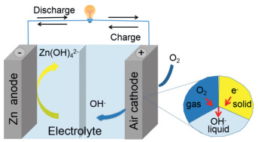

Zn + 4(OH) ⁻ → Zn (OH)₄+ 2 e ⁻ (anode )
O 2 + 2 H ₂ O + 4 e ⁻ → 4 (OH )⁻ ( cathode ) .
Zn + 1/2O₂ → ZnO (cell ) .

Zinc–air batteries cannot be used in a sealed battery holder since some air must come in; the oxygen in 1 liter of air is required for every ampere-hour of capacity used.
Applications:

- The important applications of the zinc–air batteries are as power sources for hearing aids, medical devices, and pagers.
- Another attractive use of zinc–air batteries is as a temporary, disposal power pack for mobile phones.
- Large-scale batteries for industrial uses, for example electric fences and railway power supplies.
Limitations:

- The major disadvantage is their limited power output, which is mainly due to the inadequate performance of air electrodes.
- The other major disadvantage is the dependence of both performance and operating period on ambient conditions such as humidity and temperature.

- Secondary cells (or) secondary batteries:
Cells in which the cell reaction can be reversed by passing direct electric current in opposite direction. Thus a secondary battery may be used through a large number of cycles of discharging and charging.
Ex: Lead battery, Li ion battery
Q.WRITE A SHORT NOTE ON LITHIUM CELLS?
- First, note that lithium-air technology is different from the lithium-ion technology that is used in everything from smart phones to battery electric vehicles.
- Briefly, Li-ion batteries move lithium ions through an electrolyte from negative electrode to positive electrode during discharge and back when being recharged.
- Lithium-air technology is fundamentally different.
- On discharge, its lithium ions combine with oxygen in the air and produce lithium oxide, Li₂O₂, at the positive electrode
- In recharging, this oxidation is reversed, the ions returning to the negative electrode and the oxygen released to the air.
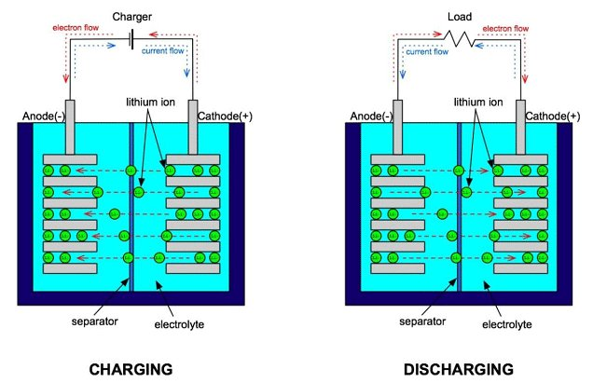
- In a typical Li-O₂ cell, the negative electrode is composed of lithium and the positive electrode is a porous material.

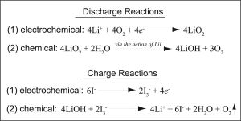

Advantages of Lithium-ion Battery
- A lithium-ion battery pack loses only about 5 precent of its charge per month.
- High specific energy and high load capabilities with Power Cells.
- High capacity, low internal resistance, good columbic efficiency.
- Simple charge algorithm and reasonably short charge times.
- Low self-discharge (less than half that of NiCad and NiMH).

Limitations of Lithium-ion Battery:
- Requires protection circuit to prevent thermal runaway if stressed
- Degrades at high temperature and when stored at high voltage
- No rapid charge possible at freezing temperatures (<0°C, <32°F)
- Transportation regulations required when shipping in larger quantities.
- They are extremely sensitive to high temperatures. Heat causes lithium-ion battery packs to degrade much faster than they normally would.

Q.WHAT IS FUEL CELLS?

- A fuel cell is a device that generates electricity by a chemical reaction. Every fuel cell has two electrodes, one positive and one negative, called, respectively, the anode and cathode.
- The reactions that produce electricity take place at the electrodes.
- Every fuel cell also has an electrolyte, which carries electrically charged particles from one electrode to the other, and a catalyst, which speeds the reactions at the electrodes.
- Hydrogen is the basic fuel, but fuel cells also require oxygen. One great appeal of fuel cells is that they generate electricity with very little pollution–much of the hydrogen and oxygen used in generating electricity ultimately combines to form a harmless byproduct, namely water.
- One detail of terminology: a single fuel cell generates a tiny amount of direct current (DC) electricity. In practice, many fuel cells are usually assembled into a stack. Cell or stack, the principles are the same.

Q. EXPLAIN THE WORKING OF H₂-O₂ FUEL CELLS. GIVE ITS APPLICATIONS.

- A hydrogen fuel cell is an electrochemical cell that uses a spontaneous redox reaction to produce current that can do work.
- The reaction between hydrogen and oxygen can be used to generate electricity via a fuel cell.
- The working of this fuel cell involved the passing of hydrogen and oxygen into a concentrated solution of sodium hydroxide via carbon electrodes. The cell reaction can be written as follows:

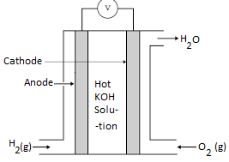

Cathode Reaction: O₂ + 2H₂O + 4e– → 4OH–
Anode Reaction: 2H₂ + 4OH– → 4H₂O + 4e–
Net Cell Reaction: 2H₂ + O₂ → 2H₂O

- However, the reaction rate of this electrochemical reaction is quite low.
- This issue is overcome with the help of a catalyst such as platinum or palladium.
- In order to increase the effective surface area, the catalyst is finely divided before being incorporated into the electrodes.

Applications for hydrogen fuel cells:

  - Generation of electricity as a back up to traditional methods in case of emergency.
  - Use as a source of power in remote locations where a mains supply is not available.
  - Stand-alone power supplies for installations such as telecommunications providers where no mains supply is available.
  - Use as a power supply for modes of transport such as cars, buses, trains or boats.
  - As portable power generators.

Q. EXPLAIN THE WORKING OF PROTON-EXCHANGE MEMBRANE FUEL CELLS. GIVE ITS APPLICATIONSProton-exchange membrane fuel cells (PEMFC), also known as polymer electrolyte membrane (PEM) fuel cells, are a type of fuel cell being developed mainly for transport applications, as well as for stationary fuel-cell applications and portable fuel-cell applications.
Working:
- A fuel cell is an electrochemical device that directly converts the chemical energy of reactants (a fuel and an oxidant) into electricity
- In a PEMFC, hydrogen is oxidized at anode to produce H⁺ ions, which migrate through the PEM to the cathode.
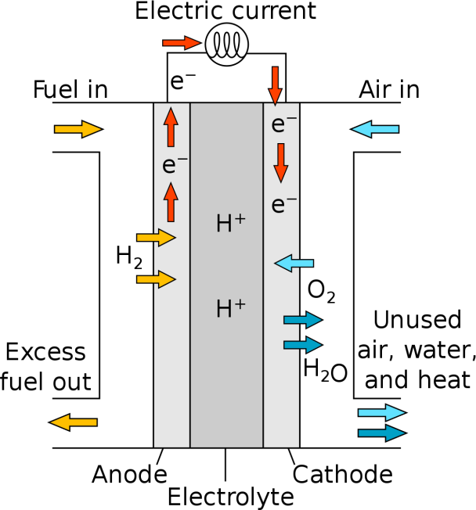
- Reduction of oxygen takes place at cathode to form O²⁻ ions, which combine with the H⁺ ions to form H₂O.

Equations:

Anodic reaction: | H₂ → 2 H⁺ + 2e⁻
Cathodic reaction: | ½O2 + 2e- + 2H+ → H2O
Overall reaction: | H2 + ½O2 → 2H2O

Applications:
- The major application of PEM fuel cells focuses on transportation primarily because of their potential impact on the environment, e.g. the control of emission of the greenhouse gases (GHG).
- Other applications include distributed/stationary and portable power generation.
Limitations:
- PEM fuel cells can only operate within a limited temperature range, typically between -40 and 120°F. Limited by pressure PEM fuel cells require a specific operating pressure, typically between 0.5 and 5 bars.

IMPORTANT QUESTIONS

ELECTROCHEMISTRY AND APPLICATIONS
- Explain about the working of Electrochemical cell?
- Write the Nernst equation and calculate the cell potential for single electrodes?
- Discuss about the Potentiometric- potentiometric titrations (redox titrations)?
- Describe the Concept of conductivity and conductivity cell?
- Discuss about the Conduct metric titrations (acid-base titrations)?
- Explain about the Electro chemical sensors?
- Write a short note on Potentiometric sensors with examples?
- Write a short note on Aerometric sensors with examples?
- Explain about the construction of Primary cells?
- Explain about the construction & working of Zinc-air battery?
- Write a short note on Secondary cells?
- Explain about the working of Lithium-ion batteries and including cell reactions?
- Write a short note on Fuel cells?
- Explain about the working of Hydrogen-oxygen fuel cell?
- Write a short note on Polymer Electrolyte Membrane Fuel cells (PEMFC) ?

UNIT IV

Polymer Chemistry
INTRODUCTION:
- Matter is composed of many small units called molecules, which are in different sizes and shapes and associated with atoms. Polymers are giants or macro molecules which play a vital role in our daily life and provide the basic needs of our life (food, clothing and shelter).
- The word polymer was derived from Greek word ‘poly’= ‘many’ and ‘mers’ = ‘parts /units’.

Polymer:
It is defined as a high molecular weight compound (macro molecule) made by linking together a large number of small molecules called monomers.
Ex: PVC, Polyethylene, Starch, Poly styrene, Proteins, DNA etc

EXAMPLES
1. POLY VINYL CHLORIDE
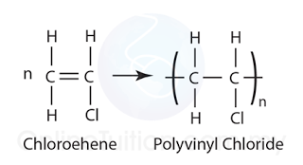

- POLY ETHYLENE
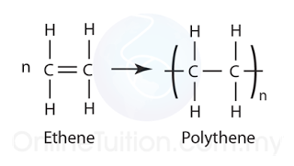
Monomer:
The basic repeating units present in a polymer are called monomer.

- Ex: Vinyl chloride is a monomer of PVC.
- Ethylene is a monomer of poly ethylene.
- Glucose is a monomer of starch.
- Styrene is a monomer of polystyrene.
- Amino acids are the monomers of proteins.
- Nucleotides are the monomers of Nucleic acids.

Degree of polymerization:
The number of repeating units (or) monomers present in the polymer is called as degree of polymerization. They may be hundreds (or) thousands (or) ten thousands

Mol.wt of polymer
Degree of polymerization (D.P) =
Mol.wt of monomer

Molecular wt of polymer = D.P X Mol.wt of monomer.

Q.WHAI IS FUNCTIONALITY?
- The number of bonding sites (or) reactive sites present in a monomer is called as functionality.
- Each monomer should have minimum two bonding sides for polymerization.
  - If the functionality of monomer is 2, the resulting polymer is linear (or) straight chained. Ex: Ethylene, styrene, vinyl chloride.
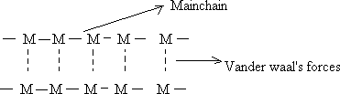

  - If the functionality of monomer is three (trifunctional), Cross linked three dimensional polymers are obtained.
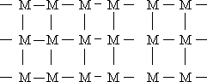
Ex: Bakelite.
  - If a mixture of bi functional and tri functional monomers is present, branched chain polymers are formed.
Ex: Buna – S – Rubber.

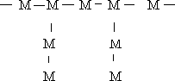
TYPES OF POLYMERIZATION REACTIONS:
- Addition polymerization
- Condensation polymerization
- Co-polymerization
- Coordination polymerization

- ADDITION POLYMERIZATION OR
CHAIN GROWTH POLYMERIZATION.

Addition polymers are formed by combining monomers without removing any by-product molecules. Unsaturated compounds such as Alkenes, alkadienes, and their derivatives are used as monomers in addition to polymers. This polymerization process consists of a series of reactions, each of which consumes a reactive particle and produces another similar particle, resulting in a chain reaction.
The polymerization reaction is also known as chain polymerization or chain growth polymerization because it occurs in stages that lead to an increase in chain length, with each stage producing reactive intermediates for use in the next stage of chain growth. This type of polymerization reaction, like other chain reactions, involves an initiator, which could be a free radical or a cation.
Depending upon the nature of the reactive species involved, the addition polymerization occurs by the following three mechanisms:
a. Free radical addition polymerization
B.Cationic polymerization
C.Anionic polymerization
However, the free radical addition polymerization is most common.

1.Free Radical Addition Polymerization

*In the presence of a free radical generating initiator (catalyst) such as benzoyl peroxide, acetyl peroxide, tert-butyl peroxide, and others, a variety of alkenes or dienes and their derivatives are polymerized. For example, heating or exposing a mixture of ethene and a small amount of benzoyl peroxide initiator to light results in the polymerization of ethene to polythene.
Mechanism of Free Radical Addition Polymerization
Free radical addition polymerization proceeds in three steps:
--Chain initiation
-Chain propagation and
-Chain termination
I. Chain initiation: The reaction begins with the addition of a free radical formed by peroxide to the ethene double bond, resulting in the formation of a new and larger free radical. This is known as the chain initiation step.
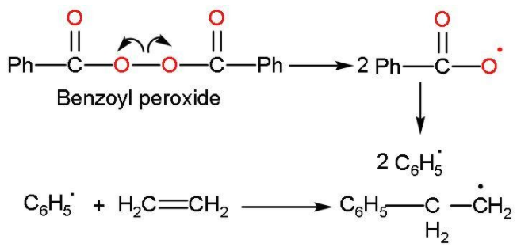
II. Chain propagation: The new free radical reacts with a double bond of monomer to form a larger free radical. The formed radical reacts with another alkene molecule to form a larger free radical. This procedure is repeated until the radical is destroyed. These are known as propagation steps.
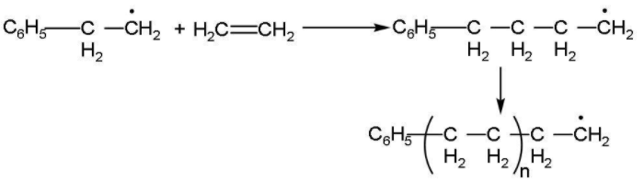
III.Chain terminating step: The product radical thus formed reacts with another radical to form the polymerized product and step is called the chain terminating step. In the termination step, these free radicals can combine in different ways to form polythene. One way of termination of chain is:

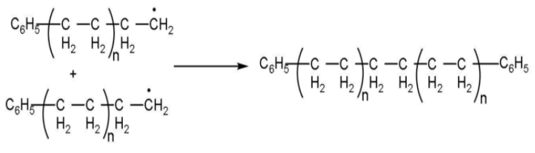

Step-Growth Polymerization Or Condensation Polymerization

It is a form of a step-growth polymerization where smaller molecules or monomers react with each other to form larger structural units (usually polymers) while releasing by-products such as water or methanol molecule. The by-products are normally referred to as condensate.

Step-growth polymerization, or condensation polymerization, is commonly employed to produce polyesters and nylons. Small molecules such as water are eliminated by the chemical reaction in step-growth polymerization. Below is an example for making nylons:

R-NH₂+R′COOH→R′CONHR+H₂O
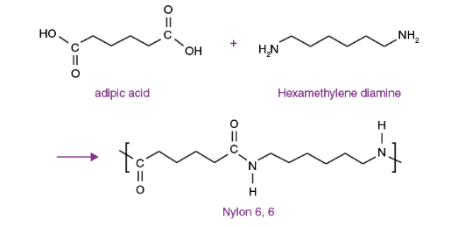

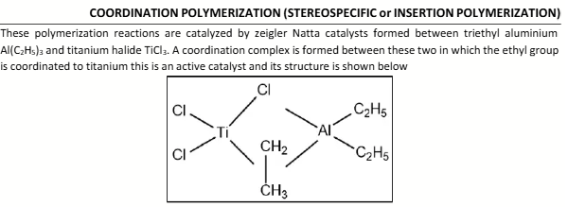
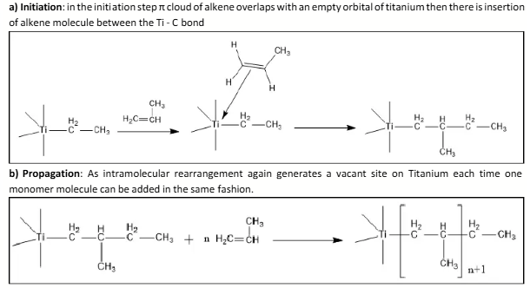

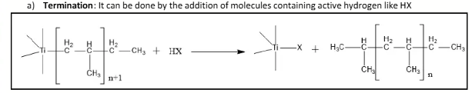

Plastics:
- An organic substance with high molecular weight, which can be moulded in to any desired form when subjected to heat (or) pressure in the presence of catalyst is called as plastic.
- The term plastic must be differentiated from resins.
- Resins are basic binding materials, which from a major part of the plastic and which actually undergo polymerization and condensation reactions during their preparations
- However, the term resin and plastic are considered as synonyms.

Advantages:
Now a days, plastics play a important role in daily life because of their certain unique properties.
- Light in weight
- Transparent
- Low maintenance cost
- Chemically inert
- Corrosion resistance
- Insect resistance
- Easy transportability
- Easy workability
- Impermeable to water
- High resistance to abrasion
Disadvantages:
- Low heat resistance, so combustible
- High softness
- Poor ductility
- Major pollutant not degraded by soil
Uses:
- For Making many house hold articles
- For making furniture
- For making electric goods

TYPES OF PLASTICS
Plastics are classified in to two types
- Thermo plastics
- Thermo setting plastics.

THERMO PLASTICS
These are the products of addition polymerization
- They have either linear(or)branched structure

- They soften on heating &stiffen on cooling.

- They are soft ,weak & less brittle

- Soluble in organic solvents.

- They can be remoulded ,reshaped and reused

- They can be reclaimed from waste.

- Examples: PVC,PE.PTEF…etc

THERMO SETTING PLASTICS

1. These are the products of condensation polymerization.

- They have three dimensional cross linked network structures.

- They don’t soften on heating.

- They are hard, strong& more

brittle.

- In soluble in organic solvents.

- They cannot be re moulded and hence cannot be reused.

- They cannot be reclaimed from waste& hence cannot be recycled.

- Examples:Bakelite.Nylon-

6,6…..etc

Q. WRITE THE PREPARTION, PROPERTIES AND USE OF THE FOLLOWING COMPUNDINGS?

i) POLY VINYL CHLORIDE (PVC)
PREPARTION:

- Poly Vinyl Chloride is obtained by heating a water emulsion of vinyl chloride in presence of a small amount of benzoyl peroxide or hydrogen peroxide in an auto clave under pressure.
PROPERTIES:

- It occurs as a colorless rigid material.

- It is having high density and low softening point.

- It is resistant to light, atmospheric oxygen, inorganic acids and alkalis.
- It is most widely used synthetic plastic.

APPILICATIONS

- It is mainly used as cable insulation, leather cloth, packing and toys.

- It is used for manufacturing of film, sheet and floor covering.

- PVC pipes are used for carrying corrosive chemicals in petrochemical factories.
ii).BAKELITE

PREPARTION:

It is obtained by the condensation reaction of phenol with formaldehyde in the presence of either an acid or base catalyst. The initial product could be linear product novalac is used in paints.

PROPERTIES;

- Bakelite is one of the oldest synthetic materials available.

- It is strong hard with good creep resistance and excellent electric properties.

- Unfortunately the material is only available in dark colors it is attack by alkaline and oxidizing agent.

APPILICATIONS
  - It is used for making electric insulator parts like switches, plugs, switch boards etc.
  - For making moulded articles like telephone parts cabinet of radio and television.

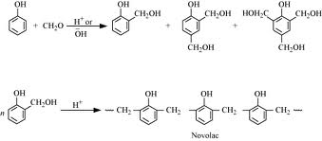
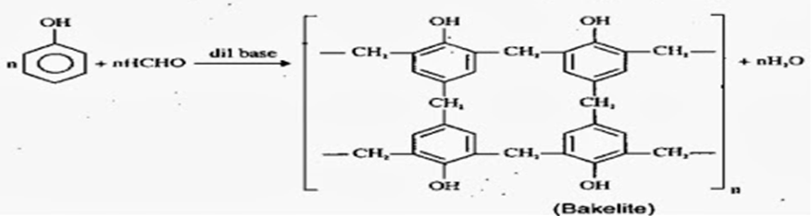

iii). Teflon
Preparation

- Teflon is prepared by heating tetra flouro ethylene in the presence of peroxides or ammonium per sulphate catalyst at high pressures.
PROPERTIES OF TEFLON:
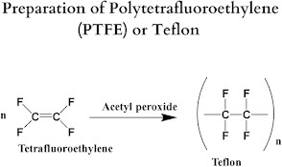
- Teflon is flexible and inert to solvents and boiling acids even to aqua regia and is stable up to 598K temperature.
- It has a low coefficient of friction and low dielectric constant due to the highly symmetric structure of the macromolecules.
- It has good insulating power in hot and wet environments.
- Teflon maintains high strength, toughness, and self-lubrication at low temperatures of -
268.15 ℃.

APPLICATIONS OF TEFLON:

- Teflon is used for making non-stick utensils due to its great chemical inertness and high thermal stability.
- It is also used for making gaskets, pump packing, valves, seals, non-lubricated bearings, filter cloth, etc.
- It is also used as electrical insulations in connector assemblies, cables, and in printed circuit boards.
- Teflon film is also widely used in the production of carbon fibre composites as well as fiberglass composites.

- Nylon 6, 6
PREPARATION:
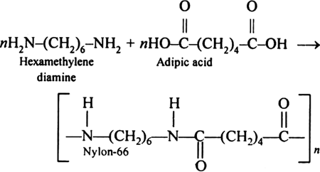
- Nylon-6, 6 is prepared by condensation polymerization of hex methylene diamine with adipic acid at high temperature and pressure.
PROPERTIES:

- Nylon6, 6 has high tensile strength.
- It also provides a very good resistance to photo degradation.
- Nylon 6, 6 also has good advantage over industrial products because it reduces moisture sensitivity in raw products and has a high dimensional stability and melting point.
- Nylon 6, 6 has long molecular chains resulting in more hydrogen bonds, creating chemical springs and making it very resilient.
- Nylon 6, 6 is an amorphous solid so it has a large elastic property and is slightly soluble in boiling water.
- Nylon 6, 6 is very stable in nature.

APPLICATIONS:
- Nylon 66 is frequently used when high mechanical strength, rigidity, good stability under heat and/or chemical resistance is required.
- It is used in fibres for textiles and carpets and moulded parts.

iv).CARBON FIBRES
PREPARATION:
- About 90 percentage of carbon fibres are made by using the poly acrylonitrile (PAN) process.
- The remaining 10 percentage are made using either the rayon or petroleum pitch process.
- Gases, liquids and other materials used in the manufacturing process create certain effects, qualities and grades of carbon fibre.
Properties:
- Physical strength, specific toughness, light weight.
- Good vibration damping, strength, and toughness.
- High dimensional stability, low coefficient of thermal expansion, and low abrasion.
- Electrical conductivity.
- Biological inertness and x-ray permeability.
Applications:
Carbon fibre-reinforced composite materials are used to make aircraft and spacecraft parts, racing car bodies, golf club shafts, bicycle frames, fishing rods, automobile springs, sailboat masts, and many other components where light weight and high strength are needed.

RUBBER (ELASTOMERS)
- The polymers which possess the property of elasticity are called as rubber.
- Rubbers are high polymers, which have elastic properties in excess of 300%.
- The molecular weight of raw rubber is about 1,00,000 to 1,50,000 Daltons.
- Most of the Indian production comes from kerala state.

NATURAL RUBBER:
It is a high polymer of polyisoprene, which are arranged in Cis – Configuration (functional groups are arranged on the same side).
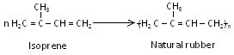

- Natural rubber is mainly produced from the milk of the rubber tree “Havea brasiliensis”.
- Small quantities of natural rubber is also produced from the milk of a shrub known as “guayule”.

PROCESSING OF NATURAL RUBBER:
- The milk of rubber tree is called latex.
- It is a collodial emulsion consists a 25 – 45% of rubber and the reminder are protein and resinous materials
- The Latex was collected by cutting the bark of rubber trees.
- There after the Latex is diluted with water and filtered to eliminate dirt present in it. The Latex then coagulates by the addition of acetic acid (or) formic acid.
- The coagulated rubber is called as crude rubber. It is then made (or) rolled out in to sheets.
- The rubber sheets are dried under sunlight or mild heat and then subjected to further processing of rubber.

- Crepe rubber: To the crude rubber, a small amount of sodium bi-sulphite is added to bleach the colour and passed into rollers which produce one mm or more thickness sheets which are dried in air about 40 to 50⁰C. The dried thin sheet of rubber are known as crepe rubber.

- Smoked rubber: The crepe rubber sheets are placed inside smoke rooms maintaining a temperature 40 to 50⁰C for 4 days. The dried rubber sheets are called smoked rubber, which are sent to rubber factories for further processing.

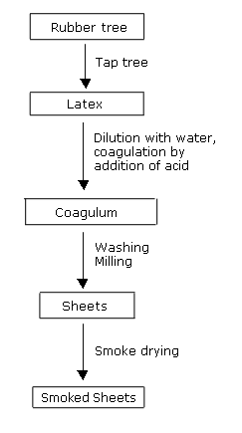

Q.WHAT IS THE DRAWBRACKS OF NATURAL RUBBER?

- It is a plastic in nature it become soft at high temperature and is too brittle at low temperatures.

- It can be used in temperature ranges 10⁰C to 60⁰C
- It is weak it tensile strength is only 200kg/cm²

- It has large water absorption capacity

- It is nonresistant to on polar solvents like vegetable
- It has little durability

- It is poor resistance to organic solvents like CCl₄, Benzene petrol etc.
- It has only more thickness.

- It has more elasticity

Q.WRITE SHORT NOTE ON VULCANIZATION RUBBER AND ITS ADVANTAGES?
Vulcanization discovered by Charles Goodyear in 1839.

- It consists of heating the raw rubber at 100 – 140⁰C with sulphur.
- The combine chemically at the double bonds of different rubber spring and provides cross-linking between the chains.
- This cross-linking during vulcanization brings about a stiffening of the rubber by anchoring and consequently preventing intermolecular movement of rubber springs.
- The amount of sulphur added determines the extent of stiffness of vulcanized rubber.
For example, ordinary rubber (say for battery case) may contain as much as 30% sulphur.
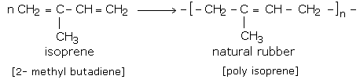
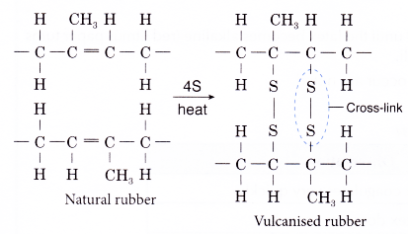
ADVANTAGES of VULCANIZATION;

  - It has a good tensile strength is 2000kg/cm²

  - The tensile strength increase.

  - Vulcanized rubber has excellent resilience.

  - It has boarder useful temperature range (-40 to 100⁰C)

  - It has better resistance to moisture, oxidation and abrasion.

  - It is resistance to organic solvents like CCl₄, Benzene petrol etc.

  - It has only slight thickness.

  - It has low elasticity.

APPLICATIONS:

- Motor vehicles: Some elastomers like thermosets don’t melt easily, making them efficient in building seals.
- Consumer products: This comprises the widest range of products starting from shoe soles to baby pacifiers and many more miscellaneous.
- Constructions: Adhesives and sealants materials enfolded under elastomers, which are an unavoidable part of any constructions. Especially for filling the gaps.
- Industrial products: Elastomers are hugely used in making industrial tools, appliances, belts, moulds, lubricants, etc.
- Wire and cable: Material needed to build wires should have high resistance to heat, be easily reshaped (elongated), and provide insulation. Elastomers like neoprene are perfect for this.
- Medical products: Medical field needs a wide range of products like prosthetics, lubricants.

Q. WRITE THE PREPARTION, PROPERTIES AND USE OF BUNA-S (SBR) (GR-S)?

Preparation:

It is made from monomers 1, 3-butadiene and styrene in the presence of a catalyst, cumene-hydroperoxide. This copolymer contains about 75% 1,3-butadiene and 25% styrene.

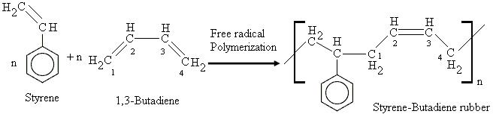

PROPERTIES:

- Good abrasion resistance (It can with stand scratching) and high load bearing capacity
- It is decomposed in oil, waste water and ozone.
- It cannot with stand strong force.
- It acts as an electrical insulator.
- Poorer resilience (rebounding)
- Strong and tough polymer
- Chemical resistance.

USES:

It is used to

- Make tyres that filled with compressed air.

- Make rubber sealing joints between metal parts, chewing gums and coated papers.

- Insulate electrical wires. Used for making wires and cable insulations.

- It is used in the foot wear industry for making shoe soles and footwear components.
- Make under surface of foot in shoe and heel of shoe
- Used as tank linings in chemical industries and as an adhesive.

ii).Buna –N
PREPARATION:
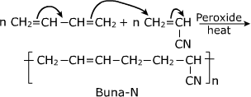
- Buna-N is obtained by co-polymerisation of 1,3-butadiene and acrylonitrile in the presence of a peroxide catalyst.

PROPERTIES:

- Buna-N is resistant to oil, fuel and other chemicals means more Buna-N higher the resistance to oil but flexibility of the material is less.
- It is resistant to aliphatic hydrocarbons.
- It has tensile strength of >=10N/mm2 as well as excellent abrasion and compression set resistance.
- It is not resistant to solvents.
- It can be attacked by ozone, ketones, esters and aldehydes.

APPLICATIONS:

- Buna-N is used in the automotive and aeronautical industry to make fuel and oil handling hoses, seals and grommets.
- It is used to make protective gloves in the nuclear industry.
- Buna-N latex is used in the preparation of adhesives and as a pigment binder.

Q.WHAT IS CONDUCTING POLYMERS? EXPLAIN THE DIFFERENT TYPES?

CONDUCTING POLYMERS:
 Conducting polymers have electrical conductivity in between a standard polymer and a metal.

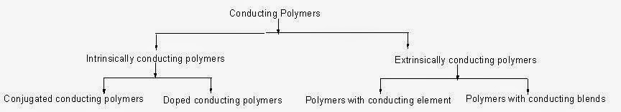

I. Intrinsically conducting polymers:
In this type of polymers, the electrical conductivity is due to repeated double bonds.
These are two types.

- Conjugated conducting polymers:
- When bonding and non-bonding orbitals are overlapping over the complete chain of polymer,valence and conduction bands are formed with some band gap.
- When electric field is applied, the electrons from valence band jumps to conduction band.
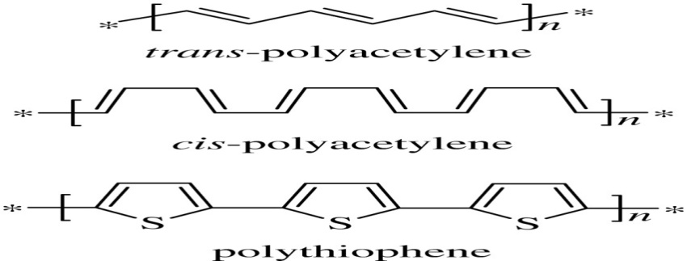

ii.Doped Conducting polymers:
o The conductivities of general polymers can be increased by inserting either positive or negative charge on the polymer chain with charge transfer agents.
- There are two types of doping conducting polymers.
a. p-doped conducting polymers
b. n-doped conducting polymers
a. p-doped conducting polymers:

- These can be gotten by inserting a positive charge on the conducting polymer using an oxidizing agent.
- Two positive charges are formed in the polymer chain from the first and second oxidations by the removal of electrons.
- These positive charges travel to the nearby carbon atoms along the polymer chain in opposite direction to conduct electricity.

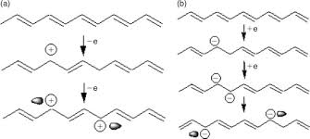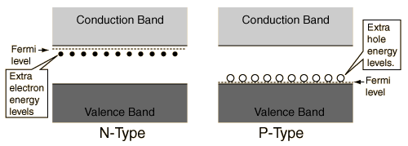

- n-doped conducting polymers:
- These can be gotten by inserting a negative charge on the conducting polymer using a reducing agent.
- Two negative charges are formed in the polymer chain from the first and second reductions by the addition of electrons.
- These negative charges travel to the nearby carbon atoms along the polymer chain in opposite direction to conduct electricity.

Extrinsically conducting polymers:

The polymers show the conductivity due to outside addition of elements into them.

there are two types of polymers in this.

i).Conductive elements filled polymers.
ii ).Blended conducting polymers.

i. Conductive elements filled polymers:

- It is a polymer gotten by filling conducting elements like carbon block, metallic fibers, metal oxides etc.
- The polymer acts as binder to join the conducting elements.
- A polymer starts to show the conductivity at minimum concentration of conductive element added. The minimum concentration of this is called Percolation threshold.

Disadvantages:
- Decrease in the tensile (means extension) strength.
- Breaks easily after a fixed length.

ii).Blended conducting polymers:
- These are gotten by chemical or physical mixing of a general polymer with conducting polymer.
- The blended conducting polymers have good physical, chemical and mechanical properties and they can be easily processed.

      - Conducting polymers are used to make
  - Electromagnetic screening materials
    - Transistors
- PV cells
- Coatings for capsules,blood bags,
- Diodes and Wires and syringes etc. switches.

Properties of Conducting Polymers:

- Conductivity polymers have high melting and softening.
- Conductivity polymers show excellent chemical, thermal and oxidative stability due to low hydrogen content and aromatic structure.
- They can be processed into a highly ordered crystalline thin film that is electrically conducting upon doping.
- They are insoluble in many common solvent.

Applications:

- They are used in the manufacturing of chemical sensors, electro-magnetic shielding, antistatic coatings, corrosion inhibitors, etc.
- They are also used in compact electronic devices such as polymer-based transitions, light- emitted diode (LEDs), and lasers.
- They are used for microwave-absorbent coating particularly radar-absorptive coatings on stealth aircraft.
Q.DISCUSS ABOUT BIO-DEGRADABLE POLYMERS?

Bio-degradable polymers:
Biodegradable matters, are generally organic materials such as plants, Animal matter or laboratory made materials that are similar to plant and animal matter to be used by
Microorganisms.

Biodegradation is the decomposition of materials by bodily functions of microorganisms.
Biodegradation is of types.
o Aerobic biodegradation
o Anaerobic biodegradation
Aerobic biodegradation:
  - It takes place in presence of oxygen.
  - Aerobic degradation is done by aerobic microorganisms like bacteria.
  - The living actions of aerobic microorganisms use up oxygen and release Carbon dioxide.

Anaerobic biodegradation:
- It takes place in the absence of oxygen.
- Anaerobic degradation is done by anaerobic microorganisms.
- The living actions of anaerobic microorganisms release methane.

Some biodegradable polymers are
1. | Starch blended polymers | 4. | Poly vinyl alcohol
(PVA)
2. | Poly cellulose acetate | 5. | Poly caprolactone
3. | Poly hydroxy alkanoates (PHB) | 6. | Poly lactic acid

1. Hydro-biodegradable plastics (HBP),

- These undergo chemical degradation by hydrolysis.
- HBP can be made from agricultural sources like corn, wheat, sugarcane and animal residues.

2. Oxo-biodegradable plastics (OBP),

- These undergo chemical degradation by oxidation.
- OBPs can be made from byproducts of oil or natural gases.

Applications

  - Biodegradable polymers should not be poisonous.
- They can be able to maintain good mechanical strength until degraded.
- They are used in surgical stitches.
- Used to make artificial cells of animal or plant body.

- Used as coatings for capsules, blood bags, syringes etc.

o They are used in the manufacturing of printed circuit board because it protects the copper from corrosion and prevents its solder ability.

Examples: Polyacetilene, Polyaniline, Polypyrrole.

Poly acetylene:

- Poly acetylene or Polyethylene having a repeating unit (C₂H₂) ₙ, is a rigid, rod-like polymer that consists of long carbon chains with alternating single and double bonds between the carbon atoms.

Preparation:

- Poly acetylene (PA) was synthesized for the first time under mild conditions via polymerization of acetylene in n-octane with AlCl₃ as a catalyst.
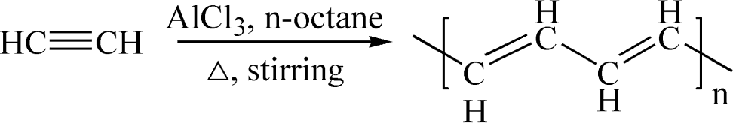

Properties of Poly acetylene:

- Films of cis-poly acetylene are flexible and can be readily stretched while trans-poly acetylene is much more brittle.
- Both cis and trans-poly acetylene show high thermal stability.
- They are insoluble in common solvents.

Applications of Poly acetylene:

- Doped poly acetylene offers a particularly high electrical conductivity therefore it can be used in electric wiring or electrode material in lightweight rechargeable batteries.
- Tri-iodide oxidized poly acetylene can be used as a sensor to measure glucose concentration.

Preparation of Polyaniline:

- Polyaniline is synthesized by oxidative polymerization of aniline.

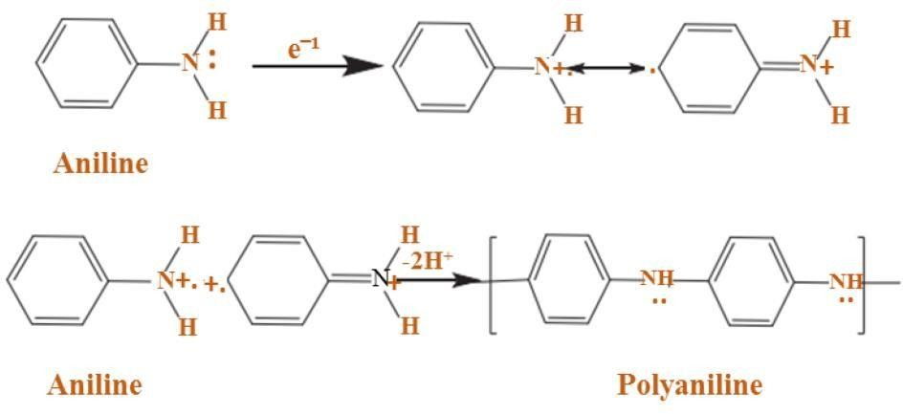

Properties of Polyaniline:

- It has great electrical conductivity in the range of 10⁻¹⁰ to 10² s/cm.

- It has band gapes of 4.3 and 2.7 ev in its reduced and oxidized forms respectively.

- It has high chemical stability.

- Poly aniline-based composition can withstand high temperatures like 230-240
℃ without significant change in electrical properties.

Applications of Poly aniline:

- It is used in the manufacturing of printed circuit boards.
- Poly aniline and its derivatives are used as the base element for the production of N-doped carbon materials.
- The colour change of poly aniline in different oxidation states can be used in sensors and electro chromic devices.

Polyglycolide or poly (glycolic acid) (PGA) Preparation:

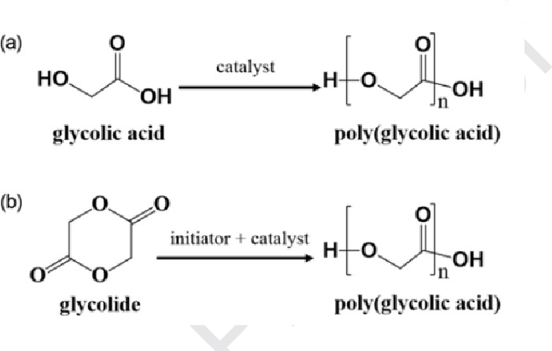
- Polyglycolide or poly(glycolic acid) (PGA), also spelled as polyglycolic acid, is a biodegradable, thermoplastic polymer and the simplest linear, aliphatic polyester. It can be prepared starting from glycolic acid by means of polycondensation or ring-opening polymerization.

Properties:

- Poly (glycolic acid) (PGA) holds unique properties, including high gas barrier properties.
- High tensile strength.
- High resistance to common organic solvents.
- High heat distortion temperature.
- High stiffness, as well as fast biodegradability and compost ability.

Applications:

- The Poly glycolic Acid surgical suture is indicated for use in in general surgery, plastic surgery, ophthalmic surgery, gynaecology and obstetrics, episiotomy, urology, orthopaedics, gastroenterology, general closure, ligatures, paediatrics.

POLY GLYCOLIC ACID (PGA) Preparation:

- The first step is the dehydration condensation of hydroxyl and carboxyl groups at equimolar concentrations to produce low-molecular-weight poly lactic acid.
- Next, coupling agents and esterification adjuvants need to be added. Their addition can modify the PLA and help amplify the chain.
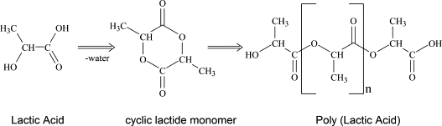

Properties:

- PLA also can be produced using the azeotropic dehydrate condensation approach.
- This polymerization technique yields high-molecular-weight. Polymers, but requires various di acids, diols, or hydroxyl acids as well as high level catalysts.
- PLA is through the ring-opening polymerization approach.
- High-molecular-weight PLA is produced from the cyclic di lactate ester.
- PLA is talented thermoplastic aliphatic polyester with good mechanical strength, great optical properties, good compost ability, high biocompatibility capacity, and good processing ability.

Applications:

- PLA, a compostable and biodegradable polymer has versatile applications in food packaging, biomedical industry, drug delivery, tissue engineering and bio composites.
- Poly lactic acid blocks and blends play significant roles in drug delivery, implants, and tissue engineering to great effect.

IMPORTANT QUESTIONS

- Explain about the functionality of Polymers and monomers?
- Discuss about the Chain growth and step growth polymerization, coordination polymerization and mechanisms of polymer formation with specific examples?
- Comparison between the Thermo Plastics and Thermo setting plastics?
- Explain about the Preparation, properties and applications of :
  - PVC
  - Teflon
  - Bakelite
  - Nylon-6,6
  - Carbon fibres.
- Discuss about the Elastomers?
- Discuss about the preparation, properties and applications of Buna-S, Buna-N?
- Write a short note on conducting polymers, Polyacetylene and polyaniline?
- Brief explanation of the Bio-Degradable polymers?
- Brief explanation of the Poly Glycolic Acid (PGA)?
- Brief explanation of the Poly Lactic Acid (PLA)?

UNIT V

Instrumental Methods and Applications

INTRODUCTION
Spectroscopy is the branch of science which deals with the study of the interaction of electromagnetic radiation with matter.
Q. DESCRIBE THE ELECTROMAGNETIC SPECTRUM?
- The electromagnetic spectrum, in simple terms, is defined as the range of all types of electromagnetic radiation.
- The electromagnetic spectrum is a range of frequencies, wavelengths and photon energies covering frequencies from below 1 hertz to above 10²⁵ Hz.
- The electromagnetic spectrum consists of a span of all electromagnetic radiation which further contains many sub ranges, which are commonly referred to as portions.
- These can be further classified as infrared radiation, visible light or ultraviolet radiation.
Principle:
The electromagnetic spectrum is a continuum of all electromagnetic waves arranged according to frequency and wavelength.
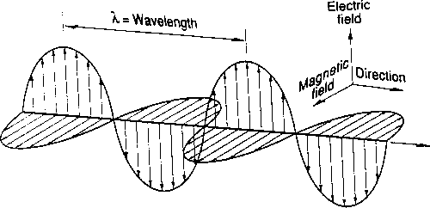
Instrumentation & Working:
The Electromagnetic Spectrum is the name given to the range of all known radiations. The spectrum is arranged in order of wavelength or frequency. The members of the EM spectrum in order are: Radio, TV, Microwaves, Infra-Red, Visible Light, Ultraviolet, X-Rays and Gamma Rays.

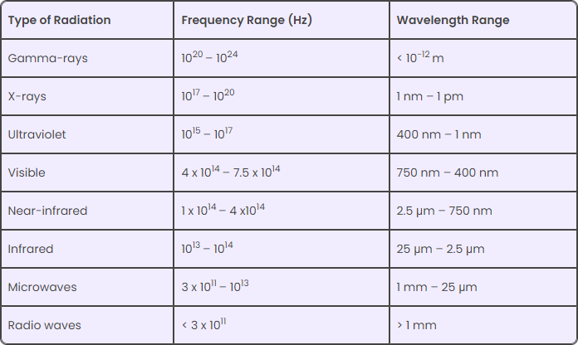

Radio: A radio basically captures radio waves that are transmitted by radio stations. Radio waves can also be emitted by gases and stars in space. Radio waves are mainly used for TV/mobile communication.
Microwave: This type of radiation is found in microwaves and helps in cooking at home/office. It is also used by astronomers to determine and understand the structure of nearby galaxies and stars.
Infrared: It is used widely in night vision goggles. These devices can read and capture the infrared light emitted by our skin and objects with heat. In space, infrared light helps to map interstellar dust.
X-ray: X-rays can be used in many instances. For example, a doctor can use an X-ray machine to take an image of our bones or teeth. Airport security personnel use it to see through and check bags. X-rays are also given out by hot gases in the universe.
Gamma-ray: It has a wide application in the medical field. Gamma-ray imaging is used to see inside our bodies. Interestingly, the universe is the biggest gamma-ray generator of all.
Ultraviolet: The Sun is the main source of ultraviolet radiation. It causes skin tanning and burns. Hot materials that are in space also emit UV radiation.
Visible: Visible light can be detected by our eyes. Light bulbs, stars, etc., emit visible light.

Significance of the Electromagnetic Spectrum:
- The electromagnetic waves in these different bands have different characteristics depending upon how they are produced, how they interact with matter and their practical applications.
- Maxwell’s equations predicted the existence of an infinite number of frequencies of electromagnetic waves, all travelling with the speed of light. This is the first indication of the existence of the entire electromagnetic spectrum.

Applications:

- The radio waves and microwaves discovered by Hertz paved the way for wireless television, radio and mobile communication.
- The visible light portion of the electromagnetic spectrum is the reason for all visual aids in daily life.
- The X-rays discovered by Roentgen proved to be useful in medicine for detecting many ailments or deformities in bones.
- The high ultraviolet radiation has energies to ionise the atoms causing chemical reactions.
- The gamma rays discovered by Paul Villard are useful for ionisation purposes and nuclear medicine.

Q.EXPLAIN THE ABSORPTION OF RADIATION?

- Electromagnetic radiation travels in wave packets known as photons that consist of propagating electric and magnetic fields.
- These photons undergo absorption when they transfer energy to atoms within a substance they are striking instead of transmitting through or reflecting off of it.
- A substance that absorbs electromagnetic radiation does not absorb it at all energies, but instead only absorbs photons with certain energy levels determined by its composition.
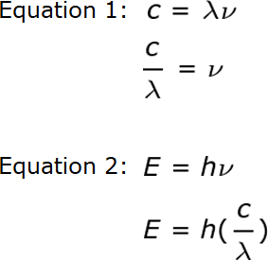
- Energy (E) can be related to the wavelength (λ) of electromagnetic radiation through frequency (ν) by combining the following two equations.
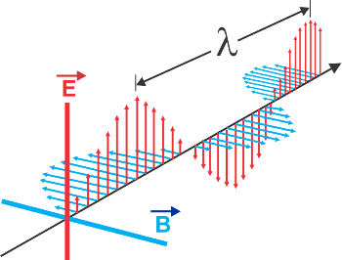

UV-IS SPECTROSCOPY
UV-Vis Spectroscopy (or Spectrophotometry) is a quantitative technique used to measure how much a chemical substance absorbs light

Q.LAW OF ABSORPTION UV SPECTROSCOPY
Lambert’s law .

It states that when a beam of monochromatic light passes through a homogenous absorbing medium, the rate of decrease of intensity of radiation with thickness of absorbing medium is proportional to the intensity of the incident radiation. Mathematically,

–Di | µ I or | −dI | = KI | (1)
Dx | µ I or |  | = KI | (1)
Dx | µ I or | dx | = KI | (1)
where k = proportionality constant

I = intensity of incident radiation

dI= infinitesimally small decrease in the intensity of radiation on passing through an infinitesimally small thickness,
dx of the absorbing medium. The negative sign on the left-hand side indicates that I decreases as x increases.

Beer’s law
Which states that: when a beam of monochromatic light is passed through a solution of an absorbing substance, the rate of decrease of intensity of radiation with thickness of the absorbing solution is proportional to the incident radiation as well as the concentration of the solution.
–dI | µ I c or | −dI | = kI c | (1)
dx | µ I c or |  | = kI c | (1)
dx | µ I c or | dx | = kI c | (1)
where k = proportionality constant

I = intensity of incident radiation

dI= infinitesimally small decrease in the intensity of radiation on passing through an infinitesimally small thickness,
dx of the absorbing solution. The negative sign on the left-hand side indicates that I decreases as x increases.

NOTE:
The expression of Beer-Lambert law is-
A = log (I₀/I) = Ecl
Where, A = absorbance
I₀ = intensity of light incident upon sample cell
I = intensity of light leaving sample cell
C = molar concentration of solute
L = length of sample cell (cm.)
E = molar absorptivity
From the Beer-Lambert law it is clear that greater the number of molecules capable of absorbing light of a given wavelength, the greater the extent of light absorption. This is the basic principle of UV spectroscopy.

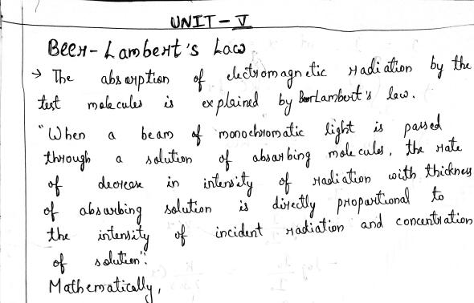
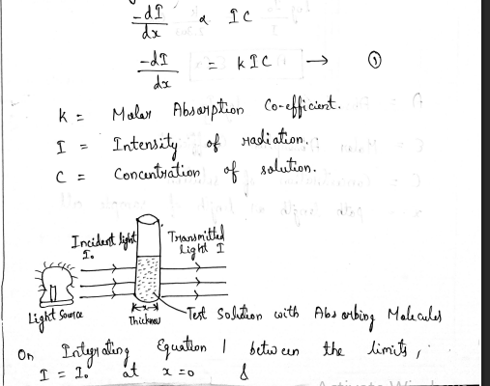

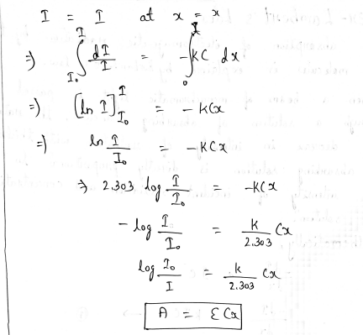

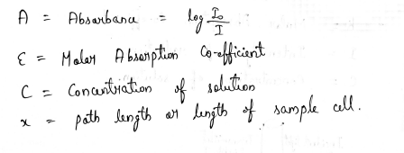

Q.INSTRUMENTATION AND WORKING OF UV SPECTROSCOPY ?
Instrumentation and working of the UV spectrometers can be studied simultaneously. Most of the modern UV spectrometers consist of the following parts-
Light Source-
Tungsten filament lamps and Hydrogen-Deuterium lamps are most widely used and suitable light source as they cover the whole UV region. Tungsten filament lamps are rich in red radiations; more specifically they emit the radiations of 375 nm, while the intensity of Hydrogen-Deuterium lamps falls below 375 nm.
Monochromator-
Monochromators generally composed of prisms and slits. The most of the spectrophotometers are double beam spectrophotometers. The radiation emitted from the primary source is dispersed with the help of rotating prisms. The various wavelengths of the light source which are separated by the prism are then selected by the slits such the rotation of the prism results in a series of continuously increasing wavelength to pass through the slits for recording purpose. The beam selected by the slit is monochromatic and further divided into two beams with the help of another prism.
Sample and reference cells-
One of the two divided beams is passed through the sample solution and second beam is passé through the reference solution. Both sample and reference solution are contained in the cells. These cells are made of either silica or quartz. Glass can't be used for the cells as it also absorbs light in the UV region.
Detector-
Generally two photocells serve the purpose of detector in UV spectroscopy. One of the photocell receives the beam from sample cell and second detector receives the beam from the reference. The intensity of the radiation from the reference cell is stronger than the beam of sample cell. This results in the generation of pulsating or alternating currents in the photocells.
Amplifier-
The alternating current generated in the photocells is transferred to the amplifier. The amplifier is coupled to a small servometer. Generally current generated in the photocells is of very low intensity, the main purpose of amplifier is to amplify the signals many times so we can get clear and recordable signals.
Recording devices-
Most of the time amplifier is coupled to a pen recorder which is connected to the computer. Computer stores all the data generated and produces the spectrum of the desired compound.
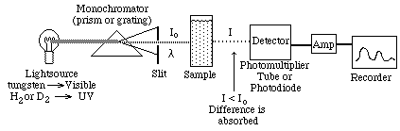

Q.THEORY OF ELECTRONIC SPECTROSCOPY:
  - All molecules contain bonded electrons.
  - When molecules are irradiated with radiation of high frequency these bonded electrons can make excitations between molecular orbitals (σ, π, σ*, π*, n).
  - Molecular orbitals are two types. They are bonding and antibonding orbitals.
  - However non-bonding orbital contains electrons which did not participate in bonding.
  - All these electronic transitions follow selection rules.
  - If the value of the molar extinction coefficient ε_{max} is more than 10⁴, then those are called allowed transitions.
  - If the value of the molar extinction coefficient ε_{max} is less than 10⁴, then those are called forbidden transitions.
The following types of electronic transitions are possible.
1.σ→σ*
  - We know that sigma bonded electrons are tightly held due to head-on overlapping(s). So to excite them high-frequency radiation is needed.
  - This high frequency (~150nm) is in the UV region.
  - However, at this frequency, the air is removed to observe excitations. Because oxygen absorbs this UV radiation (as in case of ozone layer absorbs UV radiation).
  - So this is called vacuum ultraviolet spectroscopy.
  - Methane, Propane etc hydrocarbons are detected in this region.

2. n→σ*
1.The heteroatoms like nitrogen, oxygen, sulphur etc., are having unshared pair of electrons (non- bonding electrons) when bonded with a carbon atom in carbon compounds.
2.At nearly 167–174nm frequency these transitions might occur.
Methyl alcohol, Methyl chloride etc., molecules give some spectral lines due to these transitions.

3. π→π*
1.These type of transitions occur in compounds having double and triple bonds.
2.At nearly 170-190nm frequency these transitions might occur.
3.Ethene, n-butane etc., molecules give some spectral lines due to these transitions.
4. n→π*
    - These type of transitions occur in compounds having hetero atom having unsaturated (double or triple) bonds like C=O (in CH3CHO), C=S etc.
    - At nearly 280nm frequency these transitions might occur.
    - Acetaldehyde, Acetone etc., molecules give some spectral lines due to these transitions.

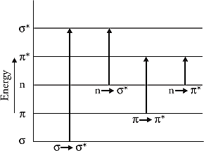
σ→σ* > n→σ* >π→π* >n→π*

Q.CHROMOPHORE AND AUXOCHROME IN THE UV SPECTROSCOPY
Chromophore-
- A chromophore is responsible for imparting colour to a compound.
- Ex: Nitro group gives a yellow colour to the compound. So the nitro group is a chromophore.
- Chromophores show characteristic absorption in UV and visible regions.
- Chromophores are generally covalently bonded groups.
- Chromophores can show π→π* and n→π* transitions.
Auxochromes-
- An auxochrome can be defined as any group which does not itself act as a chromophore but whose presence brings about a shift of the absorption band towards the longer wavelength of the spectrum. –OH,-OR,-NH₂,-NHR, -SH etc. are the examples of auxochromic groups.

Q. APPLICATIONS OF UV SPECTROSCOPY
- Identification of unknown compound.
- Cis-isomers give spectra at the shorter wavelength when compared with trans-isomers. So this spectroscopy can be used to identify cis/trans isomers.
- Used to find the presence of conjugation in molecules.
- Used to find impurities in compounds. [For example, ethyl alcohol sometimes contain benzene as an impurity. This benzene can be identified at 280nm. Benzene is toxic to human beings.]
- Used to detect hydrogen bonds.

INTRODUCTION TO IR SPECTROSCOPY
Spectroscopy can be defined as the interaction between matter and light. Infrared spectroscopy is a very powerful technique which uses electromagnetic radiation in the infrared region for the determination and identification of molecular structure as well as having various quantitative applications within analytical chemistry (Figure 1).

  - Near infrared (12820-4000 cm⁻¹): poor in specific absorptions, consists of overtones and combination bands resulting from vibrations in the mid-infrared region of the spectrum.
  - Mid-infrared (4000-400 cm⁻¹): provides structural information for most organicmolecules.
  - Far Infrared (400-33 cm⁻¹): has been less investigated than the other two regions; however, it has been used with inorganic molecules.

The low energies, typically encountered within the infrared region, are not sufficient to cause electronic transitions; however, they are large enough to cause changes in the frequency and amplitude of molecular vibrations.
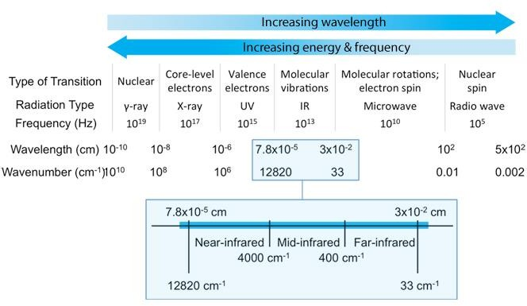
Figure 1: The electromagnetic spectrum and the infrared region.

Q.INSTRUMENTATION OF IR SPECTROSCOPY (FTIR)
The instrument consists of the following.
1. LIGHT SOURCE:
Infrared radiations are produced by electrically heating Globar or a Nernst filament to 1000–1800°C. Globar is a rod of silicon carbide, whereas the Nernst filament is a high resistance element composed of sintered oxides of zirconium, cerium and thorium.
2. FILTER OR MONOCHROMATOR:
Optical prisms or gratings are used to obtain monochromatic light. Glass or quartz cannot be used as the prism material because they absorb in the infrared region. Prisms are made of sodium chloride or alkali metal halides.
3. SAMPLE HOLDER:
Cells are made of NaCl or alkali metal halides as they do not absorb IR radiations. Solid samples are ground with KBr and made into a disc. The sample should be absolutely dry as water absorbs strongly in the IR region. Solvents used for IR are chloroform, carbon tetrachloride, carbon disulphide, etc.
4. DETECTORS:
Thermocouple based detectors are used. Light from the source is split intobeams, one of which passes through the sample and the other through the reference. The beam on passing through the sample becomes less intense. There is a difference in intensity of the two beams. This is detected and recorded and an IR spectrum is obtained.

The schematic diagram of an IR spectrophotometer is shown in Figure 17.15.

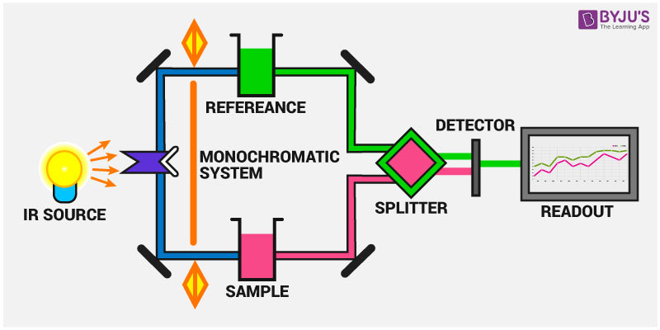

SELECTION RULE OF IR
- IR-radiation is absorbed only when a change in dipole moment of the molecule takes place.
- Complete symmetry about a bond may eliminate certain absorption bands.
- Therefore number of absorption bands observed is not exactly equal to the fundamental vibrations, some of the fundamental vibrations are IR-active while others are not.
This is governed by selection rule described below.
1) In a molecule with a centre of symmetry, the vibrations symmetrical about the centre of symmetry are IR-inactive.
2) The vibrations which are not symmetrical about the centre of symmetry are IR-active.

HERE ARE SOME EXAMPLES WHICH COULD EXPLAIN THE SELECTION RULE.
a) All the symmetrical diatomic molecules such as H₂, N₂ and Cl₂ etc. are IR-inactive.
b) The symmetrical stretching of the C=C bond in ethylene (centre of symmetry) is IR-inactive.
c) The symmetrical stretching in CO₂ is IR-inactive, whereas asymmetric stretching is IR-active.
d) Cis-dichloro-ethylene molecule shows C=C stretching bands whereas trans molecule does not show this band.

FUNDAMENTAL VIBRATION
These vibrations are arising when molecule promoted from ground state to lower excited state. The fundamental vibrations for linear and non-linear molecules are determined by following way:

Molecule | Degree of freedom
Linear | 3n-5
Non-linear | 3n-6
Where, ‘n’is number of atom present in the molecule The vibrations discuss below are fundamental vibrations.
- Stretching vibration: Distance between two atom increase and decrease but bond angle remains constant.

Types of stretching vibrations
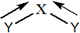
  - Symmetric stretching vibration: In this case both the atoms stretched or compressed in same direction.
  - Asymmetric stretching vibration :In this vibration one atom undergoes stretching and other atom undergoes compression and vice versa.
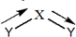
- Bending vibrations :Distance between two atom remains constant but bond angle changes. These vibrations can occur either in plane or out of plane.

Types of bending vibrations
- In plane bending vibrations:
  - Scissoring : both the atom move towards each other just like scissor.
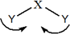
  - Rocking :both the atoms move in same direction, either in left side or right side.
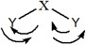
- Out of plane bending vibrations:
  - Wagging :both the atom move up and down with respect to central atom.
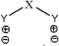
  - Twisting: one atom move up and other atom moved own with respect to central atom.
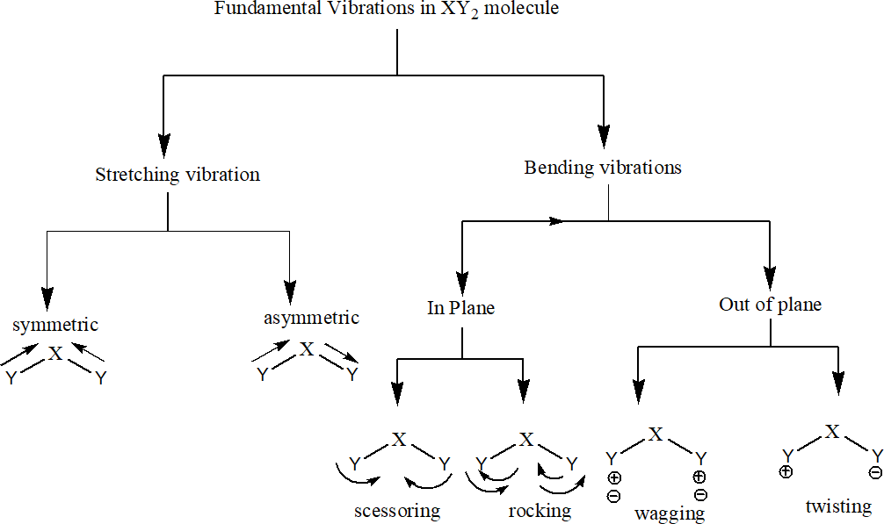
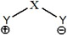

(e.g.)CO2is a linear molecule.
It can exhibit 3x3-5=4 vibrations

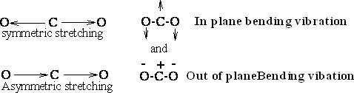

CHROMATOGRAPHY:
- Chromatography is an important biophysical technique that enables the separation, identification, and purification of the components of a mixture for qualitative and quantitative analysis.
- Proteins can be purified based on characteristics such as size and shape, total charge, hydrophobic groups present on the surface, and binding capacity with the stationary phase.

PRINCIPLE:
- Chromatography is based on the principle where molecules in mixture applied onto the surface or into the solid, and fluid stationary phase (stable phase) is separating from each other while moving with the aid of a mobile phase.
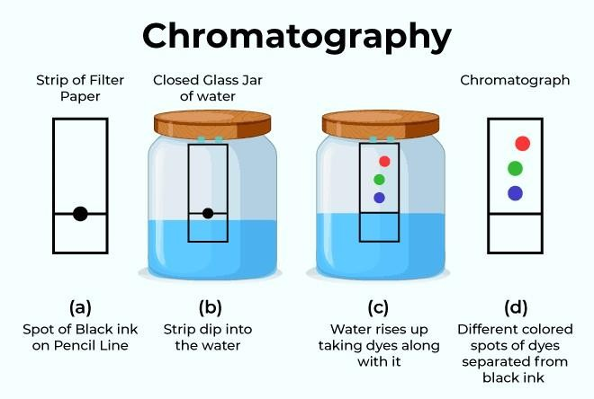
INSTRUMENTATION:
- Analyte: Analyte is the substance that is to be separated from the mixture during chromatography.
- Mobile Phase: Mobile Phase in Chromatography is the component that moves with the sample. It is either a gas or a liquid and is passed through the column where the components of the mixture are absorbed.
- Stationary Phase: Stationary Phase in Chromatography is the one that doesn’t move with the sample. It is generally a porous solid that absorbs components from the mobile phase.
- Eluent: Eluent refers to the fluid that enters and passes through the chromatographic column.
- Elute: Elute is the fluid containing the sample that exits the chromatographic column
- Elution: Elution is the process of removal or extraction of a solid by washing out it with a suitable solvent in a chromatographic column.

Q. CLASSIFY VARIOUS CHROMATOGRAPHIC TECHNIQUES ?
      - Column chromatography
      - Ion-exchange chromatography
      - Gel-permeation (molecular sieve) chromatography
      - Affinity chromatography
      - Paper chromatography
      - Thin-layer chromatography
      - Gas chromatography
      - Dye-ligand chromatography.
      - Hydrophobic interaction chromatography.
      - Pseudoaffinity chromatography
      - High-pressure liquid chromatography (HPLC).

Q.HIGH-PRESSURE LIQUID CHROMATOGRAPHY (HPLC)

- High-performance liquid chromatography (HPLC) is an analytical technique to separate, identify, and quantify components in a mixture.
- It is the main chromatography technique used in most laboratories worldwide.

Principle:
- The separation principle of HPLC is based on the distribution of the analytic (sample) between a mobile phase (eluent) and a stationary phase (packing material of the column).
Instrumentation& working:
- High Performance Liquid Chromatography (HPLC) is a process of separating components in a liquid mixture.
- A liquid sample is injected into a stream of solvent (mobile phase) flowing through a column packed with a separation medium (stationary phase).
- HPLC instrumentation is made up typically of nine basic components: mobile phase/solvent reservoir, solvent delivery system, sample introduction device, column,post- column apparatus, detector, data collection and output system, post-detector eluent processing, and connective tubing and fittings.
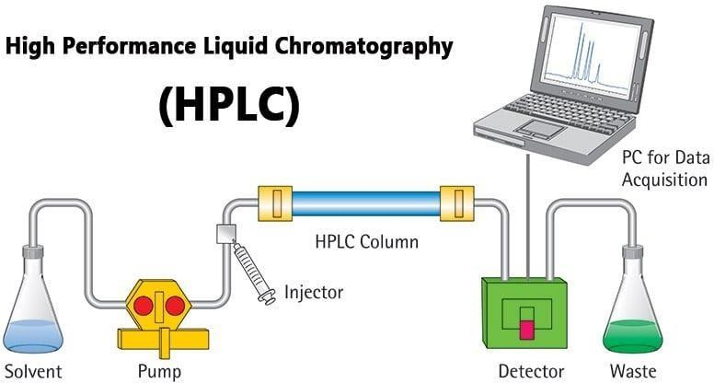

The Pump:
- The development of HPLC led to the development of the pump system.
- The pump is positioned in the most upper stream of the liquid chromatography system and generates a flow of eluent from the solvent reservoir into the system.
- High-pressure generation is a “standard” requirement of pumps besides which, it should also to be able to provide a consistent pressure at any condition and a controllable and reproducible flow rate.
- Most pumps used in current LC systems generate the flow by back-and-forth motion of a motor-driven piston (reciprocating pumps). Because of this piston motion, it produces “pulses”.

Injector:
- An injector is placed next to the pump.
- The simplest method is to use a syringe, and the sample is introduced to the flow of eluent.
- The most widely used injection method is based on sampling loops.
- The use of the auto sampler (auto-injector) system is also widely used that allows repeated injections in a set scheduled-timing.

Column:
- The separation is performed inside the column.
- The recent columns are often prepared in a stainless steel housing, instead of glass columns.
- The packing material generally used is silica or polymer gels compared to calcium carbonate. The eluent used for LC varies from acidic to basic solvents.
- Most column housing is made of stainless steel since stainless is tolerant towards a large variety of solvents.

Detector:
- Separation of analytes is performed inside the column, whereas a detector is used to observe the obtained separation.
- The composition of the eluent is consistent when no analyte is present. While the presence of analyte changes the composition of the eluent. What detector does is to measure these differences.
- This difference is monitored as a form of an electronic signal. There are different types of detectors available.

Recorder:
- The change in eluent detected by a detector is in the form of an electronic signal, and thus it is still not visible to our eyes.
- In older days, the pen (paper)-chart recorder was popularly used. Nowadays, a computer- based data processor (integrator) is more common.
Applications:
- Analysis of drugs
- Analysis of synthetic polymers
- Analysis of pollutants in environmental analytics
- Determination of drugs in biological matrices
- Isolation of valuable products
- Product purity and quality control of industrial products and fine chemicals
- Separation and purification of biopolymers such as enzymes or nucleic acids
- Water purification
- Pre-concentration of trace components
- Ligand-exchange chromatography
- Ion-exchange chromatography of proteins

IMPORTANT QUESTIONS

- Detailed explanation of the Electromagnetic spectrum?
- Discuss about the Absorption of radiation?
- Explain the statement of Beer-Lambert’s law?
- Detailed explanation of the UV-Visible Spectroscopy?
- Detailed explanation of the IR spectroscopy Instrumentation?
- List the fundamental modes and selection rules of IR spectroscopy?
- Explain about the Chromatography?
- Briefly explain the HPLC ?

B.Tech I Year I Semester (R23) Regular Examinations
CHEMISTRY
(Common to ECE and EEE)

Time: 3 hours Max. Marks: 70

PART – A
(Compulsory Question)
*****
- Answer the following: (10 X 02 = 20 Marks)
  - Write Schrodinger equation.
  - Write the electronic configuration and bond order of O ⁺.
2
  - How is n-type semi conductivity produced?
  - What are superconductors? Give two examples of superconductors
  - Calculate the electrode potential of copper, if the concentration of CuSO₄ is 0.1 M. Given that E⁰Cu²⁺/Cu = + 0.34 V
  - Define battery? Give examples for secondary battery.
  - What is stereo specific polymerization?
  - What is meant by functionality?
  - What is the importance of fingerprint region in IR spectrum?
  - State Beer’s - Lambert’s law of absorption.

PART – B
(Answer all five units, 5 X 10 = 50 Marks)
UNIT – I
2. Discuss the molecular orbital diagram of CO and find out its bond order.

OR
3. (a) Explain wave nature of electrons.
(b) Discuss π-molecular orbital’s of benzene.
UNIT – II
4. What are carbon nano materials? How are the prepared

OR
5. Explain basic concepts and applications of super capacitors?
UNIT – III

6. (a) Derive Nernst equation for a electrochemical cell.
(b) Explain the working of methanol fuel cells.

OR
7. (a) Explain conduct metric titration of strong acid and strong base with example.
(b) What is electrochemical sensor? Explain amperometric sensors with examples.
UNIT – IV

8. (a) Explain the preparation and applications of urea-formaldehyde.
(b) Write a short note on chain growth and step growth polymerization.

OR
9. (a) Explain the conducting behavior of polyaniline.
(b) Discuss any one mechanism of polymer formation.
UNIT – V
- (a) Explain IR spectrophotometer with instrumentation.
(b) Discuss the principle involved in HPLC.

OR
- (a) Explain the principle of NMR spectroscopy.
(b) Describe in brief the terms: (i) Auxochrome. (ii) Chromophore.

Code No: R23111 R23

I B. Tech I Semester Regular Examinations, JAN/FEB – 2024
Set No. 1
CHEMISTRY
(Common to EEE and ECE)

Time: 3 hours Max. Marks: 70
Question paper consists of Part A, Part B. Part A is compulsory, Answer all questions.
In Part B, Answer any one question from each unit.
*****
 |  | PART-A | (20 Marks)
1 | a) | Compare Ψ and Ψ2 |  | [2]
 | b) | Calculate bond order in CO |  | [2]
 | c) | Give the applications of Semiconductors. |  | [2]
 | d) | Classify nanomaterials. |  | [2]
 | e) | What is the importance of potentiometry. |  | [2]
 | f) | Distinguish primary and secondary cells. |  | [2]
 | g) | What is functionality of monomer, give example. |  | [2]
 | h) | Give the applications of nylon 66. |  | [2]
 | i) | Give the applications of UV-Visible Spectroscopy. |  | [2]
 | j) | Classify various chromatographic techniques. |  | [2]
 |  | PART-B | (50 Marks)
 |  | Unit-1
2 | a) | Give Schrodinger Wave equation, explain terms involved in that and its  importance. |  | [5]
 | b) | Describe energy level diagrams of O2. |  | [5]
 |  | (OR)
3 | a) | What are the postulates of molecular orbital theory. |  | [5]
 | b) | Explain π molecular orbitals of Benzene. |  | [5]
 |  | Unit-2
4 | a) | Define super conductors, explain its basic conept. |  | [5]
 | b) | Distinguish Fullerenes and Carbon nanotubes. |  | [5]
 |  | (OR)
5 | a) | Classify Supercapacitors, give its applications. |  | [5]
 | b) | Give properties and applications of Graphene nanoparticles. |  | [5]
 |  | Unit-3
6 | a) | Define electrochemical cell, Derive Nernst equation. |  | [5]
 | b) | Compare potentiometric and amperometric sensors with suitable  parameters. |  | [5]

 |  | (OR)
7 | a) | Define conductivity explain acid base conductometric titrations. | [5]
 | b) | Give brief note on Polymer Electrolyte Membrane Fuel cells. | [5]
 |  | Unit-4
8 | a) | Explain chain growth polymerization with suitable example. | [5]
 | b) | What are the conducting polymers, explain mechanism of conduction by  taking suitable example. | [5]
 |  | (OR)
9 | a) | Differentiate thermo and thermosetting polymers. | [5]
 | b) | What is the importance of biodegradable polymers, explain properties  of any one biodegrable polymer. | [5]
 |  | Unit-5
10 | a) | Explain absorption of radiation and Beer-Lambert’s law. | [5]
 | b) | Describe instrumentation of IR Spectroscopy with block diagram. | [5]
 |  | (OR)
11 | a) | Explain fundamental modes and selection rules. | [5]
 | b) | Explain the basic principle involved in chromatography and  Instrumentation of HPLC. | [5]
*****

